Arthur Langton Airy
(Herkomer student)

Over a period of twenty years, Hubert Herkomer taught about 600 students at his Art School in Bushey village. By 1914, Herkomer’s Art School had been closed for ten years but a number of former students settled in the village and the surrounding area. When Arthur Langton Airy he was killed in France in 1915, friends remembered and he was named as a Herkomer student in the Bushey Parish Magazine alongside other war casualties.
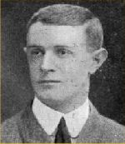
Arthur Langton Airy
Arthur Langton Airy came from a distinguished family. His grandfather, Sir George Biddell Airy, was Astronomer Royal from 1835 to 1881. During his tenure of 46 years in that role he transformed the Observatory at Greenwich, establishing it as the location of the prime meridian.
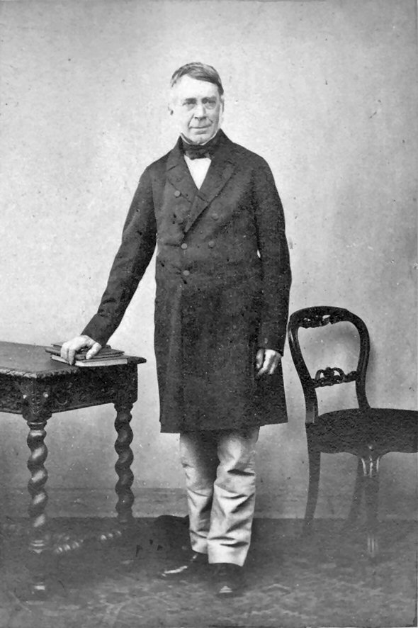
Sir George Biddell Airy
Arthur’s father, Dr Hubert Airy, was a physician and wrote one of the clinically definitive papers on migraine. Anna Airy, Arthur’s cousin, was one of the first women officially commissioned as a war artist.
Arthur, born in about 1877, was the youngest of three children and inherited his mother’s maiden name of Langton. His eldest sister, Mary, was born in Lee, at that time in Kent, while Arthur and sister, Agnes, started life nearby in Kidbrooke, just a few miles from the Greenwich Observatory. By the time he was four, the family had moved to Eastbourne but there were strong family links with Suffolk so Arthur was sent to Eaton House, a private boarding school in Aldeburgh.
The period when Arthur Langton Airy was a student at the Herkomer Art School in Bushey was probably during the late 1890s, after which he returned home to his parents, who were living in Woodbridge, Suffolk.
In 1900 Arthur joined the army but on the death of his father in 1903, he retired with the rank of Lieutenant. That same year he married Grace Wood at Easton in Suffolk and by 1911 they had settled in Worthing, where Arthur worked as an artist. Their two children, Hubert Arthur and Jack Langton, were both named after their grandparents.
Between 1899 and 1912 Arthur was a member of the Ipswich Art Club. He exhibited at the Royal Academy from 1904 until 1910, from Woodbridge in 1904, from London in1907 and from Worthing, Sussex in 1910. At the outbreak of the First World War he re-enlisted in the Northampton Regiment. Like countless other young men, he left behind his wife and children to serve his country. He was killed in action at the battle of Cuinchy in France on 11 January 1915, aged 39. He is buried at the Le Touret Memorial in France.
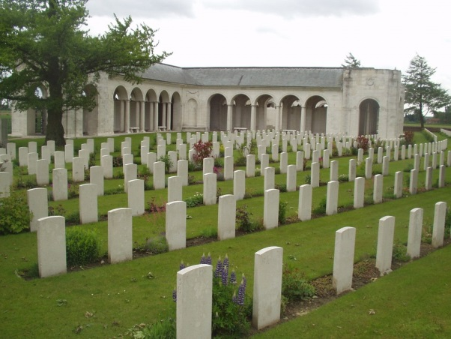

Allan Chapman, ‘Airy, Sir George Biddell’ (1801-1892) Oxford Dictionary of National Biography, 2004 online edition.
‘Women at War: The female British artists who were written out of history’, The Independent, 8 April 2011.
1881 census, Class: RG11; Piece:1038; Folio:136; Page;9; GSU roll: 1341246.
1891 census, Class: RG12; Piece:1478; Folio:21; Page:5; GSU Roll: 6096588.
1891 census, Class: RG12; Piece:1481; Folio:5; Page4; GSU Roll: 6096591.
1911 census, Class: RG14; Piece:5321; Schedule Number: 141.
This information courtesy of Anthony Copsey, www.suffolkpainters.co.uk.
The Commonwealth Graves Commission, www.cwgc.org.

