George Aish
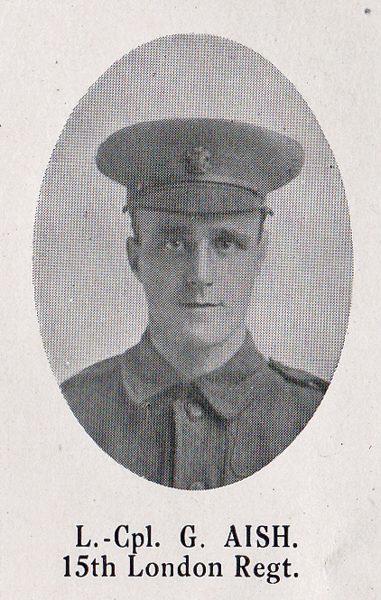
Source: The Fullerian WBGS
George Aish, of ‘Burnage’, 44 Bushey Grove Road, was the eldest son of George and Ellen Aish. He was born in 1888 in Chorlton, Lancashire and his family moved to Brixton Road, Watford in the 1890s. His father was a railway clerk and the family moved into the housing development in New Bushey created after the coming of the railway. The house still retains the name it was given more than 100 years ago. George attended Watford Grammar School for Boys from 1900 until 1902.
George Aish served as Lance Corporal 3543 in the London Regiment (Prince of Wales' Own Civil Service Rifles), 1st/15th Battalion. He was killed in action on 15 September 1916, aged 26. He is remembered with honour on the Thiepval Memorial to the Missing, panel reference: Pier and Face 13 C. He is commemorated on the Bushey Memorial, at St James’ Church and at St Paul’s, Bushey.
