James Berry Allen
James Berry Allen, born in 1888, was the youngest son of Joseph Allen, a railway labourer, and his wife, Emma. Soon after James was born, his father died and his mother moved from Watford Fields to 6 Crook Log, one of a row of small cottages on the London Road in Bushey. She worked as a laundress. By 1901, when other members of the family had left home, William, who was 20, and James, who was 12, remained with their mother. James was still there with his mother ten years later.
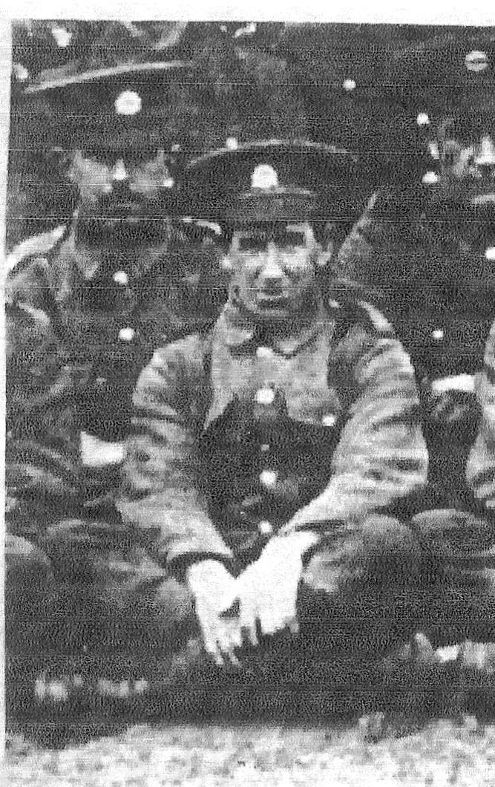
James Berry Allen
Photograph courtesy of Jill Collette
He enlisted in Watford as Private 26253 with the Bedfordshire Regiment in 1915 and transferred as Private 23452 to the Loyal North Lancashire Regiment. He was killed in action on 3 September 1916, aged 27. He is remembered with honour at the Thiepval Memorial to the Missing and commemorated on the Bushey memorial, at St James’ Church and at St Paul’s. His older brother, William Thomas Allen, was killed in action in 1918.
