Henry Godfrey W Anthony

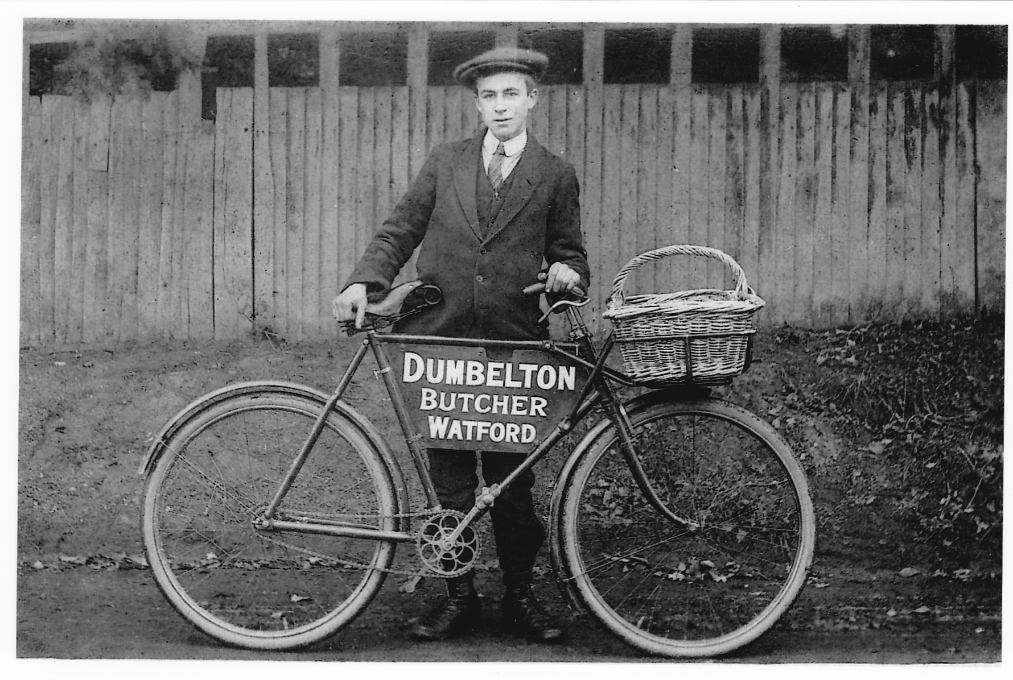

Henry Godfrey W Anthony, born in 1896 with the surname Hodkinson, was the son of Mary Ann Elizabeth Hodkinson. On 21 August 1898, she married Albert Anthony at All Saints Parish Church in Harrow Weald. The census return for 1901 shows Albert and Elizabeth, as she was then known, living at 108 School Lane, Bushey, with her son, Henry, aged four, and a daughter aged two. Albert was a bricklayer’s labourer and over the next few years he and Elizabeth had four more children and moved to 129 School Lane. Henry took on the family name and became known as Harry Anthony. In 1911, when he was fourteen, he worked for a green grocer and later was employed by Dumbelton, the butcher in Watford. Soon after war was declared Harry joined the Bedfordshire Regiment, 4th Battalion and served as Lance Corporal 23210 on the Western Front. He was close to his sister, Grace, and wrote letters to her regularly. These letters were probably censored.
Dear Grace,
I received your letter quite safely this morning. That is the first one I have had from home. I kept writing but no answers came back. I hope I will soon be back – it may not be for a long time. I believe we shall be up in the lines sometime this week. I would sooner be in England any time, for France is not an extra grand place, I’ll never leave England once I get away from these quarters.
Your ever loving brother, Harry (21 kisses)

29 July 1915
Dear Grace,
Just a few lines hoping you are quite well as I am myself. We are having a good time hear (sic), of course not quite as good as it was at the Training Camp. The sea made me very green coming over and I don’t want to cross it again yet. Food is good here as well, not much to grumble about if everything goes on as good as it is now, I shall not mind. How is mother getting on? I hope she is not worrying. I’ve met two or three chaps out of Bushey Heath.
Your loving brother, Harry

15 July 1916, Soldiers’ Christian Association Camp Home

Harry Anthony was killed in action, aged 20, on 7 February 1917. He is buried at Ancre Cemetery, Beaumont-Hamel, France and is commemorated on the Bushey Memorial on Clay Hill and at St Peter’s Church, Bushey Heath.

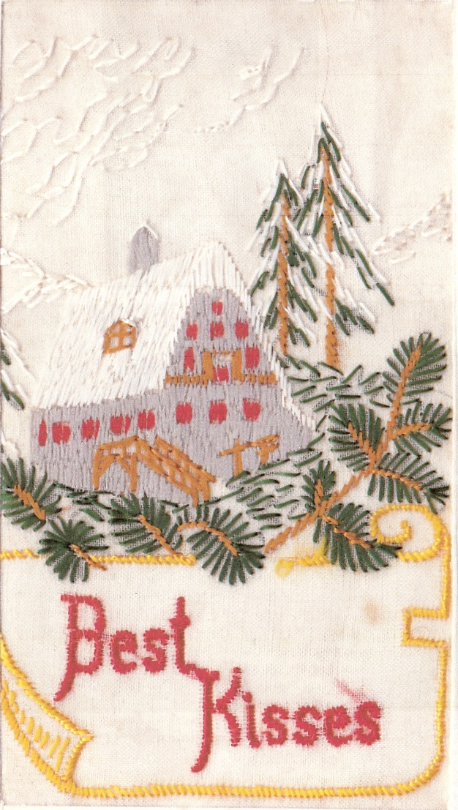
Letters and cards - courtesy of Fred Richards of Park Road, Bushey.
Harry Anthony was his uncle, Grace was his mother and Alfred Anthony was his grandfather.

