Frederick J Ashby
Frederick J Ashby, the son of Thomas and Mary Ashby, was born in about 1898 and lived at 3 Grove Cottages, Falconer Road, Bushey. He was the eldest of three children and his father was a farm labourer. He died on 16 February 1915 while serving as a Boy 1st Class 122496 on HMS Conqueror. The cause of his death is unknown, but he died while the ship was in the UK. He was buried at Flaybrick Hill Cemetery in Birkenhead on the Wirral Peninsular, England. He is commemorated on the Bushey Memorial, at St James’ Parish Church and at the Congregational Church in Bushey High Street. He was about 16 years of age.
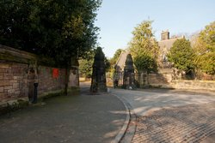
Flaybrick Hill Cemetery, Birkenhead

