Edward Stephen Ayling
Edward Stephen Ayling was born in April 1887 in Bushey. In 1881 his father, James Ayling, who came from Sussex, was living in Islington, employed as a railway clerk. He was a boarder with Robert and Sarah Conquest and their family and the following year married their daughter, Kate. James and Kate had four children but Kate died in 1890 at the age of 29. The census returns for 1891 and 1901 show James living with his children at 23 Pinner Road, Oxhey, a property they shared with others. James was now employed as an accountant to a frigate firm. Edward, the third of his four children, attended Watford Boys’ Grammar School.
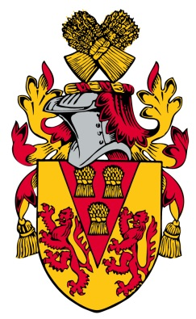
In 1911, Edward, now 24, and his sister, Kate, named after her mother, were boarding at 58 Kingsfield Road, Oxhey with the Hemming family. Edward was employed as a commercial clerk. His younger brother, Henry Conquest Ayling, also named after his mother, died the following year at the age of 23.
On 4 September 1914 Edward enlisted number 670 with the London Rifle Brigade, giving his address at that time as 25 Kingsfield Road, Oxhey where his sister, Kate, was living. His papers state that he was aged 27 years and 5 months, 5’10” in height with good vision and physical development and a ‘good character’ He served in France and was promoted to Corporal. In 1917 he was gassed and received a gun-shot wound to the thigh. In August that year he was ‘totally incapacitated’ by a lung ‘infection attributable to service in the present war’. On 25 September he was permanently discharged, suffering from ’tuberculosis of the lungs’. He received a pension of £1/12/6d a week (to be reviewed after 39 weeks), He died on 24 June 1918, aged 31. He is commemorated on the war memorial at St Matthew’s Church, Oxhey.
