Arnold Edwin Bare

Arnold Edwin Bare was the son of Thomas Edwin and Blanche Bare
He and his wife, Janie, lived at ‘Rokra’, 12 Bushey Grove Road. He joined the Artists’ Rifles in 1897 and volunteered for foreign service on 4 August 1914. He went to France with the 1st Battalion in October 1914. In August 1916 he commanded a Guard of Honour to the King and was awarded the unusual honour of Member of the Victorian Order. He also won the Territorial Force Efficiency Medal.
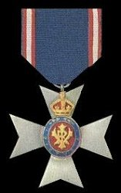
ODM of the United Kingdom: The Royal Victorian Order http://www.medals.org.uk/united-kingdom/...ngdom/united-kingdom019.ht
He served as a Captain and was killed in action, age 36, at Passchendaele on 30 October 1917, leaving his wife, Janie, with three young children. He is remembered with honour at the Tyne Cot Memorial panel 153 and is commemorated on the Bushey Memorial and at St James’ and St Paul’s churches.
