Alfred Henry Brunker Barnard
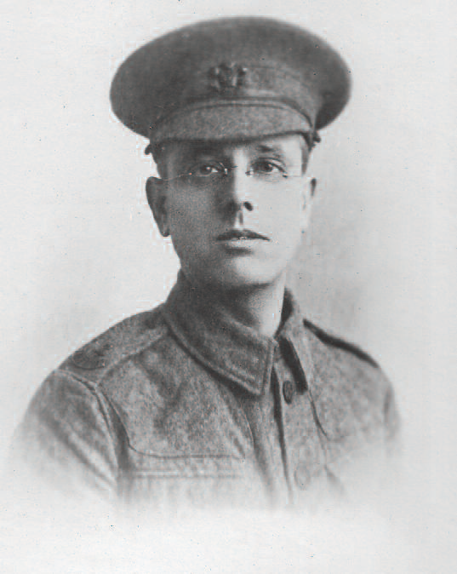
Alfred Henry Brunker Barnard, born in 1878, was the son of William and Mary Barnard of Harrow, Middlesex. Alfred married his wife, Mary, in about 1902 and they had one daughter, Millicent Gladys. By 1911 they were living at 93 Selwyn Avenue, Highams Park, Chingford, Essex, where Alfred worked for the London County Council as an assistant in the Edmonton Branch.
When he enlisted as private 534060 at Bedford as a Private in the London Regiment (Prince of Wales’ Own Civil Service Rifles), the family had moved to Oxhey. He served in the Egyptian theatre of war and was killed in action on 20 February 1918 outside the city of Jerusalem, aged 39. His wife, Mary, and his daughter, who was about 12 at the time, lived at 38 Oxhey Avenue.
Mary Barnard was one of many widows for whom the formalities surrounding the death of her loved one was a protracted and painful process. From receiving news of Alfred’s death in February 1918, it was not until 17 October 1924 that she attended the last memorial service in which his name was honoured. In the absence of a body to bury at home, she sought assurance from the Imperial War Graves Commission that Alfred had been buried and later re-interred with due reverence.
A sheaf of surviving documents testifies to the correspondence that took place. Mary received seven letters of condolence, including one containing Alfred’s last letter to her written two days before he was killed. She attended memorial services in London, in Bushey and in Harrow, where Alfred was born. In 1924 she attended a ceremony unveiling a memorial at County Hall, Westminster. She also received official condolences from the King, the Secretary of State for War and Alfred’s last employers, London County Council.
Alfred is remembered with honour at the Jerusalem War Cemetery and is commemorated on the memorials at Bushey and Oxhey Methodist Church and at St Matthew’s Church, Oxhey.
Mary Barnard died on 9 September 1937 and her daughter had Alfred’s name inscribed on the gravestone in Bushey churchyard. On 8 December 1990 she was buried there too.
