Henry William Batchelor
Henry William Batchelor was born in Kilburn, the son of Joseph and Elizabeth Batchelor. Joseph was employed as a coal porter and he and Eliza had five children. In 1900 the family moved to Hertfordshire and Joseph, who was a coal porter, died that year, aged 38. Elizabeth and her five children settled at 10 Oxhey Street, now part of Oxhey Avenue, and Henry, who had just left school, worked as a railway invoice sorter to help provide for the family. In 1905 Eliza married William Henry Woodstock, who already had a family, and moved to 42 Tucker Street, just off Watford Lower High Street. Just before the war Henry married and he and his wife, Alice, moved into 46 Tucker Street.
When war was declared, Henry enlisted as Private 5098 with his brother, Joseph, with the 3rd battalion of the Dragoon Guards. They served together in Belgium and were both killed in action on the same day, 31 October 1914.
Records show that they are one of 322 sets of brothers who served in the British Army (including the Commonwealth forces) and who are currently known to have died on the same day. They are remembered with honour at the Menin Gate Memorial to the Missing at Ypres. They are commemorated on the plaque in Bushey Baptist Church.
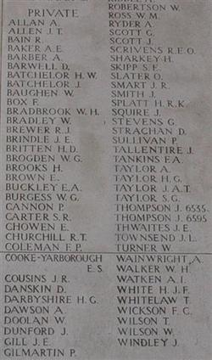
Menin Gate Memorial panel 3, Belgium

