Victor William Bates
Victor William Bates, born in Hendon, Middlesex in 1892, was the son of James Philip Bates, a dairy farmer and his wife, Annie. They had six children, one of whom died during childhood. The family home in 1901 was Burroughs Farm, Queens Road, Hendon and at the time of the 1911 census, Victor and his younger brother were employed there as milk carriers.

When Victor enlisted with the London Regiment, the 15th (County of London) Battalion (PWO Civil Service Rifles)as Private 533135, he was resident in Peterborough.

Victor Bates was on the Troopship S.S. Aragon when she sailed from Marseilles on the 17 December, arriving in Alexandria Harbour on the 30th December 1917, laden with around 2,700 troops bound for Palestine. As she arrived in a convoy bound for the port, the rest of the ships sailed onwards to Alexandria and she lay up ten miles off shore, awaiting her escort. The 9588 tons of ocean liner drifted gently as she waited within sight of land but was torpedoed by the German Submarine and minelayer the UC-34.

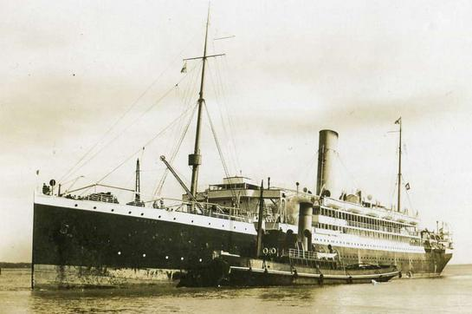

S S Aragon

The destroyer HMS Attack and every available ship within reach dashed to her rescue as she sunk quickly. Many of the men rescued and taken onto the HMS Attack had just stripped their oil drenched clothes from their bodies and laid on the deck when she too was torpedoed by the same submarine, almost blowing her in two. 610 of the 2,700 passengers on board SS Aragon were lost at sea, including servicemen like Victor Bates.

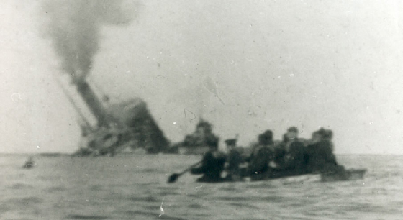

S S Aragon goes down
www.bedfordregiment.org.uk

He is remembered with honour on the Chatby Memorial in Alexandria and is commemorated on the Bushey Memorial and at St Peter’s Church, Bushey Heath. His connection with the area is currently unknown but there were several families names Bates living in Bushey at the time.

