William Henry Burney Bennett
William Henry Burney Bennett, born in about 1878 in Rangemoor, near Tatenhill, Staffordshire, was the son of William Bennett and Jemima Burney Snow. William was one of five children, two of whom died before reaching adulthood. His father was a head gardener and may have been a member of the staff at nearby Rangemoor Hall as the family home was Rangemoor Bass Gardens, named after one of the owners of the stately home. The Bennett family employed one domestic servant.
William grew up at Rangemoor but by 1901, when he was 24, he had moved to Hertfordshire to become a student at the Herkomer Art School in Bushey. He boarded with Elizabeth Rogers, an elderly widow and her daughter, who was a dressmaker, at 138 Albert Cottages, High Street, Bushey, near the foot of Clay Hill, very close to The Fishmonger’s Arms and the Meadow Studios. He was still there in 1911, joined by Herbert Gibbs, another artist. William Bennett, who was 5 ft 4ins tall and had a moustache, played hockey in Bushey and entered into many other social activities.
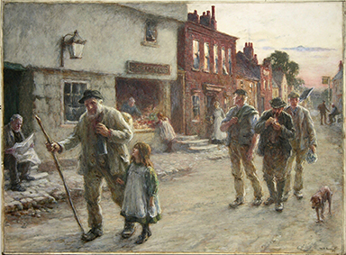
BUSHEY VILLAGE in 1905 by William Henry Bennett
Courtesy of Bushey Museum and Art Gallery
He was a friend and contemporary of Albert Ranney Chewett, who later purchased ‘Reveley Lodge’, 88 Elstree Road, Bushey Heath.
When war broke out, William enlisted with the Sherwood Foresters and served as Second Lieutenant on the Western Front. He died on 11 April 1917, aged 40. A small carving was found on his body and left to Albert Chewett. William is remembered with honour at St Leger British Cemetery in France. He is commemorated on the Bushey Memorial and at St James’ Parish Church. When his father retired, his parents moved to Bushey and lived at ‘High Level’ Merry Hill Road.

