Frank Harry Bethell

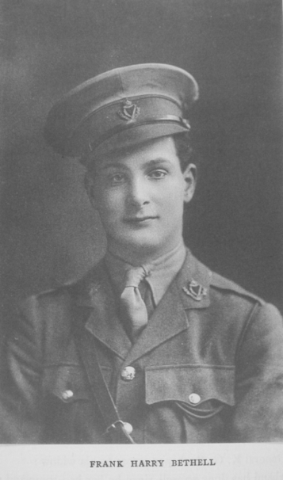
Frank Harry Bethell was the eldest son of Lord Bethell of Bushey House, Liberal MP and Director of Barclays Bank
Frank was born on 18 May 1896 at Romford Road, Essex, the eldest of six children of John Henry Bethell and Florence Wyles. His father had entered politics around 1886 and rose from a humble clerk to an auctioneer. By the 1901 census the family was living at 88 Romford Road, West Ham, where his father described himself as a Land Agent & Auctioneer living ‘on his own account’ and employing a nurse, a cook and a maid. In the 1911 census his entries are styled, ‘Bethell, John Henry, Sir, M.P., Bart’ and he became Lord Bethell in about 1912.
At that time Frank was a pupil at Harrow School. He enlisted with the 3rd Battalion of the Connaught Rangers on 20 September 1914. He joined the Expeditionary Force on 17 March 1915 and his rank of 2nd Lieutenant was confirmed on 30 May 1915. He died on 25 September 1915 at age 19, killed in action in France at the Battle of Loos. He is remembered with honour in Belgium at the Menin Gate to the Missing and in the House of Commons Book of Remembrance, 1914-1918 at the House of Lords.

