Hector Fussell Billinger

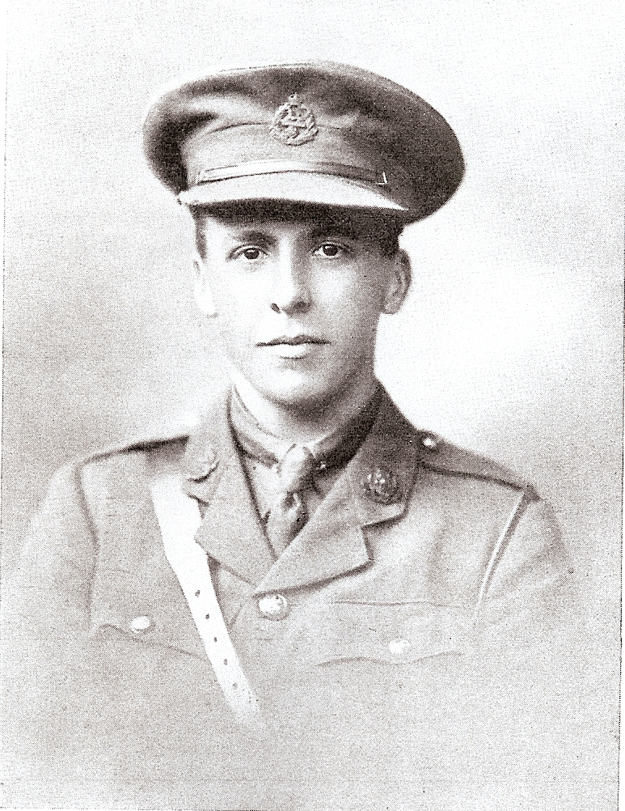

Hector Fussell Billinger, B.A. (Cantab.), was born on 18 October 1893, the son of James Fussell Billinger and Margaret Jane Billinger, of Cambridge. He was educated at the Cambridge County School, whence he proceeded to St. John's College. Here he took Second Class Honours in the History Tripos in 1914.

He had just received an appointment as History Master at Bushey when the war broke out. He immediately applied for a commission, having been a member of the Officers' Training Corps during his school and college careers. He was gazetted in October, 1914, to the 10th Battalion, East Lancashire Regiment. He went out to France in February, 1916, and acted as adjutant from March of the same year till his death on 23 November. He was killed in action, aged 23, and was commemorated at Thiepval.

In conveying sympathy to his parents the officer commanding his battalion wrote: "It is my unfortunate duty to have to inform you of the death of your son, who was killed whilst gallantly commanding his company in the front line trenches. We are very cut up about it indeed, especially myself, for, although I have only commanded this battalion for a short time, I had seen a considerable amount of your son, as he was acting-adjutant to me for some weeks. I only hope the knowledge that he has always done his duty will help you to bear your great Ioss."

He is remembered with honour at Thiepval, Pier & Face 6 C and is commemorated on the Bushey memorial and on the plaque outside the former Congregational Church in Bushey High Street.

