Harry Hickman Binyon

Harry Hickman Binyon, born in Bushey in about 1873, was the son of an auctioneer, living at 83, Grover Road, Oxhey. He was educated at Watford Grammar School.
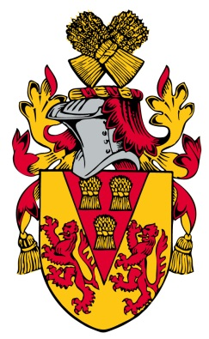
His father died and by 1901 Harry had taken over the auctioneering business. He then emigrated to Australia, where he worked as a farm labourer. He enlisted in the Australian Light Horse on 27 November 1914 and was killed in action on 30 May 1915, aged 41. He was buried at Ari Burnu Cemetery, Anzac Cove. His widowed mother, Emma Binyon, and his unmarried sister moved to 91, Grover Road, Oxhey. Harry is commemorated on the St Matthew’s Church memorial.
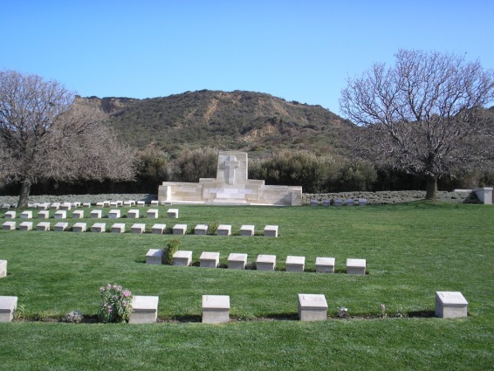
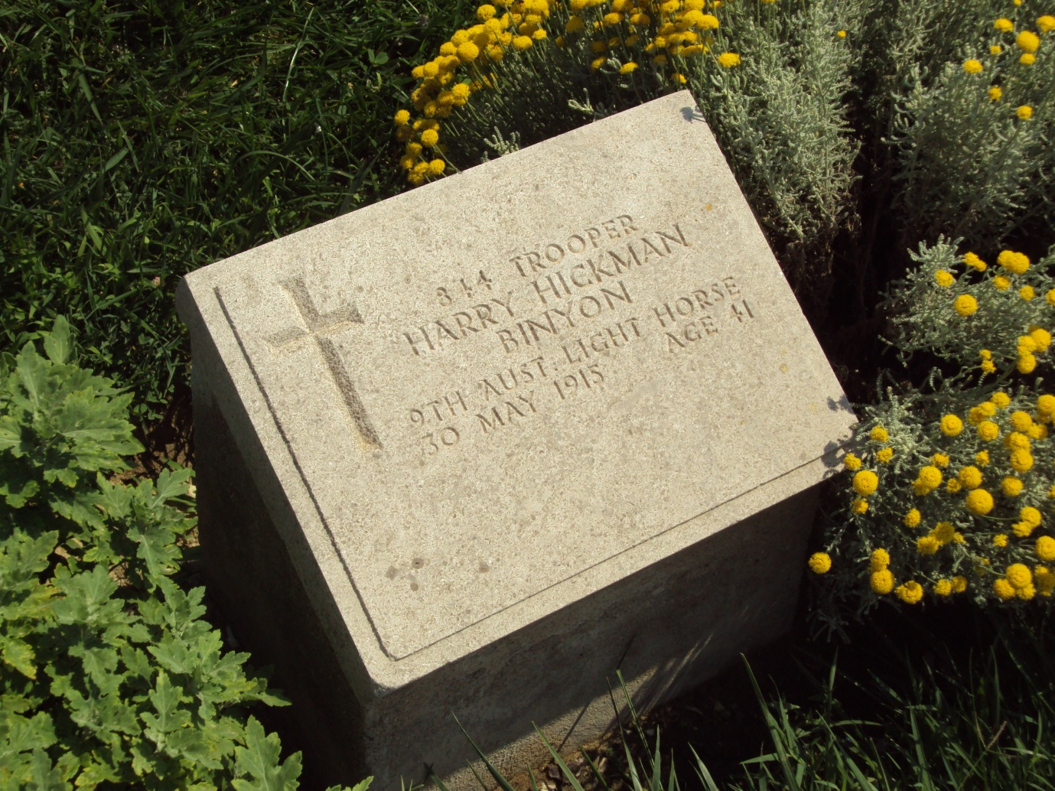
Grave of Harry Hickman Binyon
Ari Burnu Cemetery Anzac Cove Gallipoli

Photographed by Alywn Jones, June 2014

