William Millar Bird

William Millar Bird was born in 1889, the elder son of William and Jane Bird of 33 Capel Road, Oxhey. His father was a grocer and he had a younger brother, Ernest, born in about 1903. His mother helped run the grocery business. William and Ernest grew up in Oxhey.
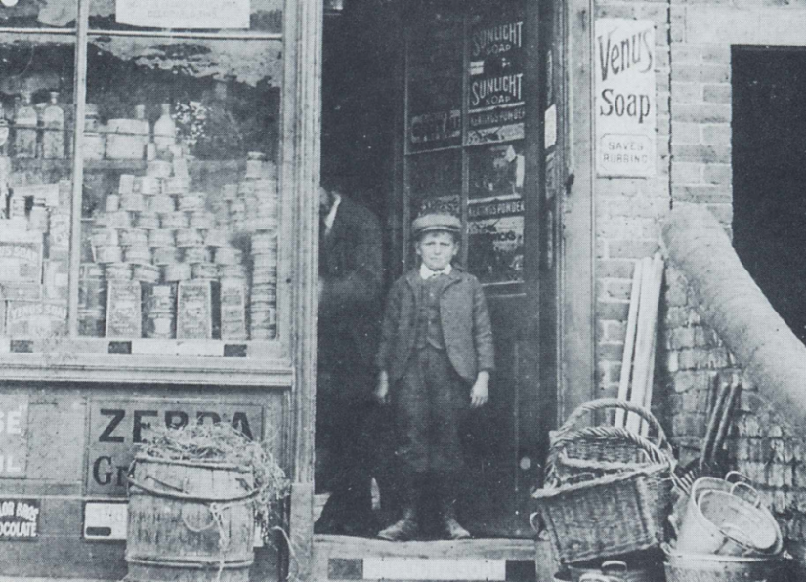

William Millar Bird in the doorway of his father’s general store at 33 Capel Road, c 1900.
From 1903 until 1905 William attended Watford Boys’ Grammar School.
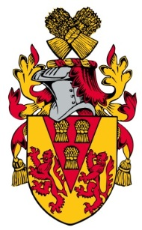
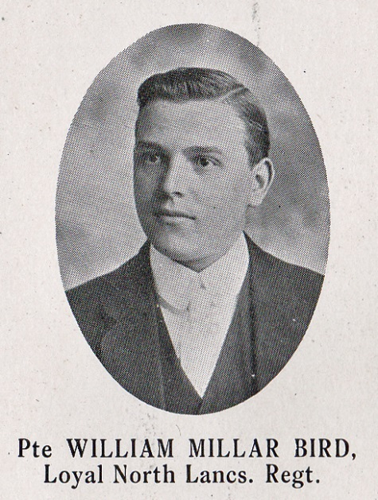
Source: The Fullerian WBGS
By 1911 the family had moved to 44 Villiers Road, Oxhey. William by this time was 21 and a bank clerk and Ernest, at 17, was employed as an insurance clerk. William joined the Bedford Regiment as a Private 26176 and transferred to 9th Battalion of the Loyal North Lancashire Regiment as Private 23500 in 1915. He died of wounds received at the Somme on 20 July 1916, aged 26. He was buried at Flatiron Copse, Mametz and is commemorated at St Matthew’s Church, Oxhey and Bushey Baptist Church, Chalk Hill.
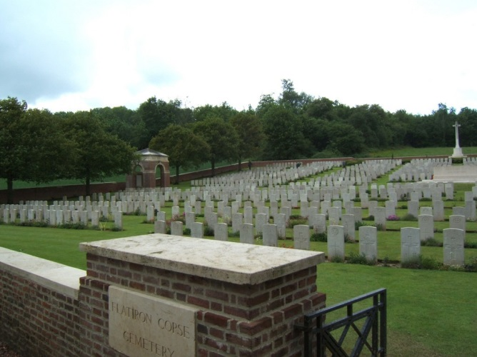
Bap

