Ronald Birkinshaw
Ronald Birkinshaw, born on 11 Dec 1892 in Totley, on the borders of Yorkshire and Derbyshire, was the eldest son of Thomas and Bessie Birkinshaw. Thomas was a domestic gardener and at the time of the 1901 census the family was living near Totley Hall, where Thomas Birkinshaw may have been employed.
By 1911 they had all moved to Hatley Park Gardens, Hatley St George, Sandy, Bedfordshire, twelve miles from Cambridge. Hatley St George was an estate village for Hatley Park and Thomas, now Head Domestic Gardener, was probably employed on the estate. Ronald, aged 18, was working as an under gardener.
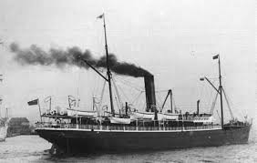
During the war Ronald enlisted as signalman Z 2317 and was serving on S S Romeo, an Admiralty-hired refrigeration ship, when it was torpedoed and sunk by German U boat 102 in the Irish Sea. He was a member of the Royal Naval Volunteer Reserve and he died on 3 March 1918. His body was not recovered for burial.
An account of the attack on SS Romeo:
The Romeo, with J Neile, master, left Scapa on 23 February 1918 bound for Liverpool. She was on Admiralty charter for carrying meat and provisions to the Fleet, but was returning to Liverpool in ballast after having called in at Stornoway, remaining there for six days. She was equipped with a twelve pound gun for defence against enemy submarines.
On 3 March 1918 at 2.40 a.m. she was about 10 miles south of the Mull of Galloway, steaming at 10 knots and zig-zagging. The weather was fine with occasional snow showers, the wind light and the sea smooth. The first officer was in charge on the bridge. There was a lookout on the forecastle head, another on the bridge and one on the gunner´s platform aft. All lights on the ship were carefully screened and no navigation lights were burning.
Suddenly a green and red light appeared off her port bow. Fearful of a collision with another ship, the order was given to show the Romeo´s navigation lights at her bow. This was a fateful mistake as she had been tricked by the German submarine U102 into giving away her exact position. Within a couple of minutes a torpedo slammed into the Romeo´s port side between the stoke hole and the engine room. The explosion was terrific and split the ship in two. At first she took a list to port, then righted herself before sinking like a stone in less than two minutes. There was no time for the crew to launch any of the lifeboats and the crew of 37 men was thrown into the water.
The two gun crew managed to cling to a swamped boat and eventually bailed it out. Shortly afterwards they spotted a sailor in the water and hauled him out into the lifeboat, but he later died at about 10.00 a.m. At daylight the two gunners managed to get the mast and sail up before being picked up by the steamship Ardgarvel at 11.00 a.m. and were later landed at Greenock.
The only other survivor was the wireless operator, who was picked up by a trawler and landed at Holyhead by the patrol boat Kilgobnet at 11.00 a.m. on 4 March.

Adrian Corkill 26/06/2008

After the war Ronald’s father moved to Hertfordshire to become a gardener at Caldecote Towers Gardens (now Immanuel College) on Elstree Road, Bushey Heath. The area was in the jurisdiction of Aldenham and before the A 41 was built, it was possible to cross the fields from Bushey Heath to Letchmore Heath via Hilfield Lane and there were close links between the two villages. Ronald is commemorated on the memorial in St Peter’s Church, Bushey Heath and on the memorial on the village green in Letchmore Heath, near Aldenham.

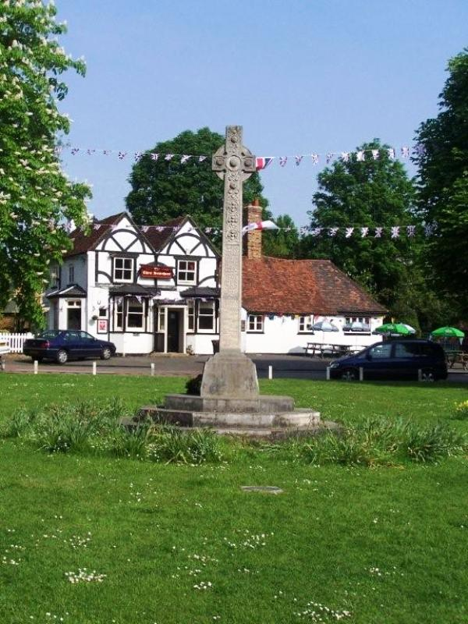
Letchmore Heath
Photographs Copyright © Dai Bevan 2008

Photographs Copyright © Dai Bevan 2008

