Charles Blackwell
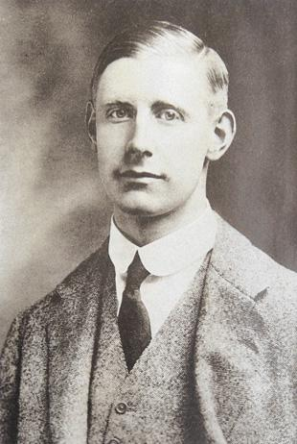
Samuel Blackwell and his wife, Elizabeth, of the Crosse and Blackwell family, brought up their 11 children at Brookshill House, Harrow Weald. In 1910, at the age of 69, Samuel inherited the Manor House at Chipperfield and became a great benefactor to the village. In 1915 Samuel and Elizabeth celebrated their Golden Wedding, but it was not a happy year for them as news came that their son, Charles, serving as Second Lieutenant in the 4th Battalion of the Royal Fusiliers, had been killed in action on 20 July 1915, aged 32.
He was buried at Ridge Wood Military Cemetery in Belgium, grave II. G. 2.
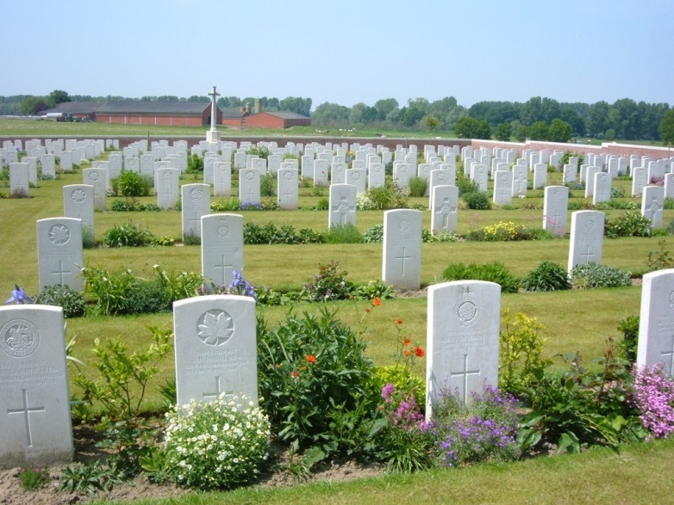
The following year, a second son, William Gordon, known as ‘Don’, was also killed in Flanders. After the war in 1922, Samuel and Elizabeth had the Chipperfield Social Club built in their memory. Samuel never got over his loss. His health deteriorated and he died in January 1923. Today ‘Blackwell’s’, which stands next to the Common, is a social club and café.
Charles and his brother, William Gordon Blackwell, are commemorated on the St Matthew’s Church Memorial, Oxhey, near ‘Oxhey Place’, a family home of the Blackwells.

