William Gordon Blackwell
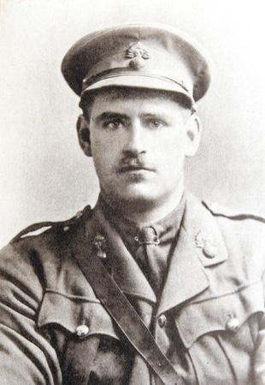
William Gordon Blackwell, known as ‘Don’ was the seventh son of Samuel and Elizabeth Blackwell and was born in 1885. Educated at Mr. Herbert Bowden-Smith's Preparatory School at Bengeo and privately, he joined his brother Robert in the firm of Blackwell Brothers, and became a member of the Stock Exchange in 1908.
On the declaration of war he enlisted straightway in the Honourable Artillery Company and was sent to the French front in September 1914, obtaining a commission in the 4th Royal Fusiliers in 1915.
He fell at Flers, in the battle of the Somme, on 6 October 1916, being then attached to the 8th Royal Fusiliers. One of his Commanding Officers wrote of him: ‘I saw a great deal of him and he naturally endeared himself to me by his kind nature and manliness of character. I deplore his loss; the nation has lost a gallant soldier and a great gentleman.’ His Major wrote: ‘He was a grand soldier; he could get the utmost out of men and did so, but they all worshipped him.’
Lieutenant Blackwell married in 1910 Nina Mary, daughter of the late Middleton Moore O'Malley and Mrs. O'Malley of Westport, co. Mayo, and leaves a widow and one son.
Source: Stock Exchange Memorial Book
He has no known grave and is commemorated on Thiepval Memorial on the Somme, Pier and Face 8 C 9 A and 16 A.
In 1910 Samuel Blackwell inherited the Manor House at Chipperfield but the extended Blackwell family owned Oxhey Place so Charles and William Gordon Blackwell are commemorated on the St Matthew’s Church Memorial.

