Horace Vincent Blight

Horace Vincent Blight, born in 1887, was the son of Francis and Lizzie Blight from Islington. His father, a prominent Baptist, was a constructional engineer with literary talent, who for 25 years was the Chairman of Charles Griffin and Company, a London publishing house well-known for technical books. He and his wife had two children, Horace and Marianne, and the family lived in Islington before moving to Hampstead and then to Wealdstone. Horace was educated at Merchant Taylors’ School, which at the time was in London. He then joined his father in the Charles Griffin publishing firm, where he was soon made a director. In 1913 he married Mabel King and they made their home at 31 Oxhey Road, Watford.

Horace enlisted with the Army Service Corps and gained a commission as a Lieutenant. He was award the Military Cross for conspicuous gallantry and devotion to duty.

The citation reads: ‘This officer was in command of the centre column of a raiding party and led his detachment with great courage and initiative. Having cut through a belt of wire he made his way to the rear of the enemy’s post, where he made prisoners of the occupants before his own men came up. He maintained excellent control of his party and the rapid precision of his movements greatly contributed to the success of the raid’.

He was killed in action on 15 June 1918, aged 30. He is remembered with honour at Sandpits British Cemetery, Fouquereuil in France and is commemorated at Bushey Baptist Church and at St Matthew’s Church, Oxhey.

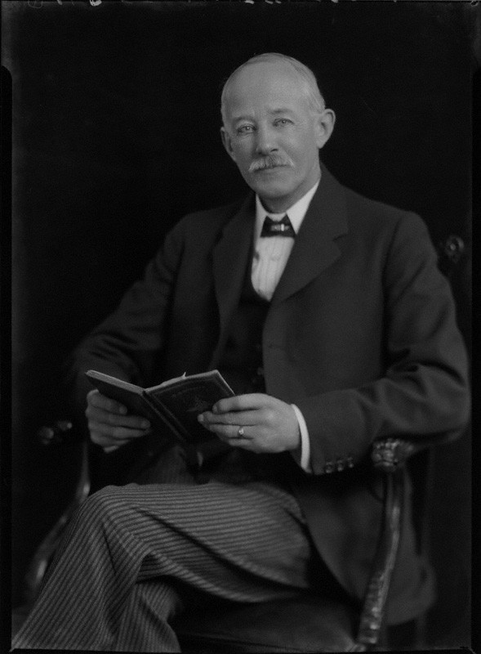
Francis James Blight, father of Lieutenant Horace Vincent Blight MC
© National Portrait Gallery, London by Lafayette (Lafayette Ltd) Photograph Collection

‘The crushing sorrow of Mr Blight’s life came in 1918, when his son, Horace Vincent Blight, MC, was killed in action in France, whilst leading his men in a successful attack on the enemy machine guns. Horace was a most lovable personality of fine attainments, who, after a brilliant school career at Merchant Taylors’, entered the service of Charles Griffin & Co as a secretary and was speedily made a director. He continued the family tradition of Christian service as a joint secretary with his father of the Western Group and joint auditor of the London Baptist Property Board Ltd. He revealed gifts and a culture which suggested he might attain the highest position in the denomination.

Source: The Blight Family – Seymour J Price www.biblicalstudies.org

