Frederick Bloom
Frederick Henry Bloom was born in about 1891. Little is known about him but in 1901 he was living as a boarder with the Darville family at 69 Clay Hill near Sparrows Herne, Bushey. William Darville was a hay binder and he and his wife, Mary, had a seven year-old son. The 1901 census return records Frederick Bloom as 10 years old, a boarder of birthplace unknown. Also boarding with the Darville family was nine year-old William G Thorp, whose birthplace was also unknown. The 1911 census shows William and Mary Darville and their son still living at the same address, with two more boys as boarders of birthplaces unknown.
By 1911 Frederick Bloom had left the Darville’s home. His service identity as Private 150315 with the Canadian Infantry and his death on 6 December 1916 is currently unconfirmed, but a Frederick Bloom is commemorated on the Bushey Memorial on Clay Hill and at St Peter’s Church, Bushey Heath.

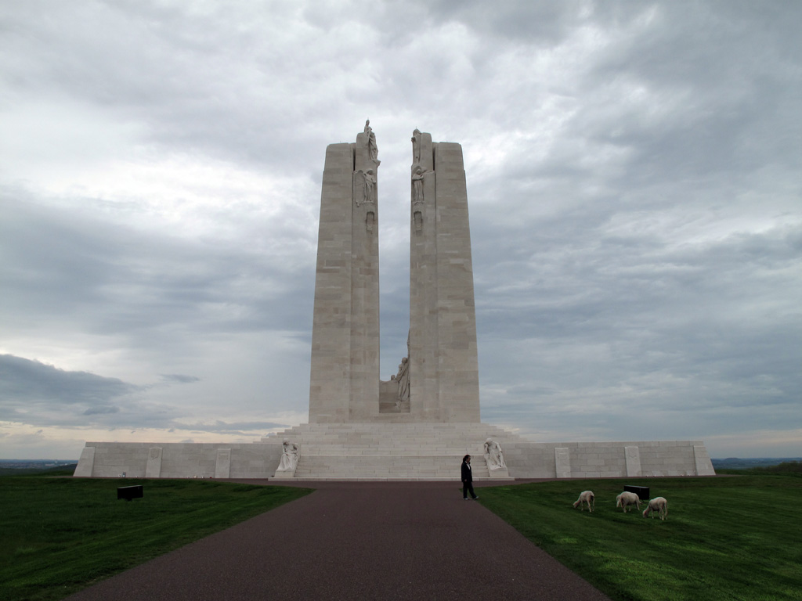
Canadian Vimy Memorial, France

