John Lionel Calvert Booth
(Former Herkomer student)

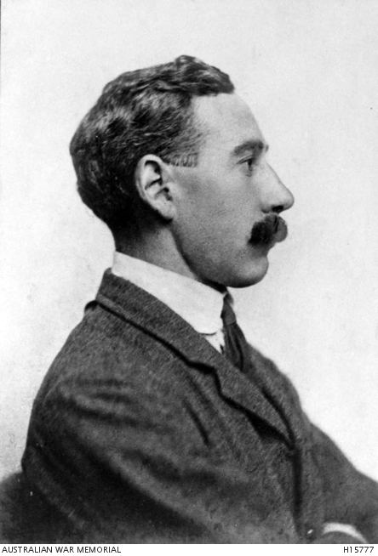

WWI Pictorial Honour Roll of West Australians
John Lionel Calvert Booth, the son of John Bainbridge Booth and Margaret Alice Gardom, was born on 28 August 1876 in Killerby, in the North Riding of Yorkshire. His father was a land agent, a farmer of 490 acres and a breeder of shorthorn cattle. John had a younger sister, Kathleen and the family home was Killerby Hall, where they employed a butler, a groom and four female servants. As a child John showed artistic talent, illustrating and writing stories for the rest of his family. Later he loved to draw hunting scenes, which had formed a large part of his childhood, as both his parents were keen members of the Bedale Hunt. In 1886, when he was ten, his father died. The family then moved to Wanstead in Essex and John went as a boarder to Forest School, a public school near Epping Forest.
In 1896 he became a student at the Art School founded in Bushey, Hertfordshire, by the German artist, Hubert Herkomer. The census of 1901 shows John was a boarder with the Kipling family at 16, Falconer Road in Bushey village. On 26 July 1905, he married Margaret Caroline Dockerill, the daughter of Joseph Dockerill and Catherine Barnes, who was also a student at the Herkomer Art School. She was known as ‘Daisy’. John became a journalist and, as a member of the Volunteer Battalion of the Yorkshire Regiment, a war artist during the Boer War and the Balkan conflict of 1912/13, where he reported for Punch. John and Margaret had two sons, both born in West Chiltington, Sussex.

Early in 1914, the family emigrated to Western Australia, where they purchased a property at Gnowangerup and named it ‘New Killerby’. When war broke out, John enlisted as a Lieutenant in the ANZAC expeditionary forces. He died at sea, aged 38, on 28 April 1915 as a result of wounds received at Gallipoli, three days earlier. He was buried at sea and is commemorated on the Lone Pine Memorial in Turkey. Among his possessions returned to his wife was his beloved banjo, which went everywhere with him.

His elder son, John Calvert Booth known as ‘Jack’, born on 4 June 1906, died on 13 June 1944 in France at the age of 38. His younger son, Arthur Frank Calvert Booth, born on 1 January 1909, died on 12 July 1941 in Germany at the age of 32. John’s wife, ‘Daisy’, died in Cambridge in 1969, aged 94.

Ltn John Lionel Calvert Booth is commemorated at St. Mary's Parish Church, West Chiltington, Sussex.

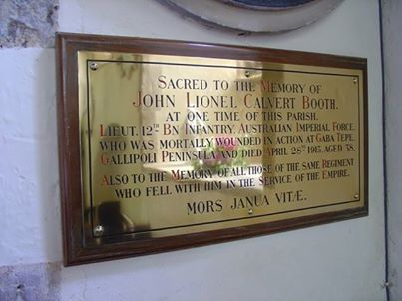

Sources: Ancestry.com; www.awm.gov.au freepages.genealogy.rootsweb.ancestry.com/~akrb61/.../calverts/d10.htm‎ ; R.B.L Peterborough
