William Leslie Booth

William Leslie Booth was born in Finchley in1886, the eldest of three sons in a family of the five children of Edwin and Henrietta Booth. At the time of the 1891 census, when William was 5, the family was resident at Lincoln Circus, Standard Hill in Nottingham. His father ran a coal merchant business and employed three servants. By 1901 they were settled in Finchley and made their home on Hendon Lane. William does not appear in the 1911 census so may have enlisted in the army and been serving abroad.

In 1913 he married Daisey Maud Harter, who was born in Portugal in 1893. Her father was a Portuguese commercial correspondent, who returned from Portugal to live in Watford. By 1911 the Harter family was settled at 8, Hillside Road, Bushey. William served as a Captain with the London Regiment and died of wounds on 28 May 1915. He was buried at Boulogne Eastern Cemetery in France. After the war his wife, Daisey, continued to live at 8, Hillside Road, Bushey. His name does not appear on any of the Bushey memorials.

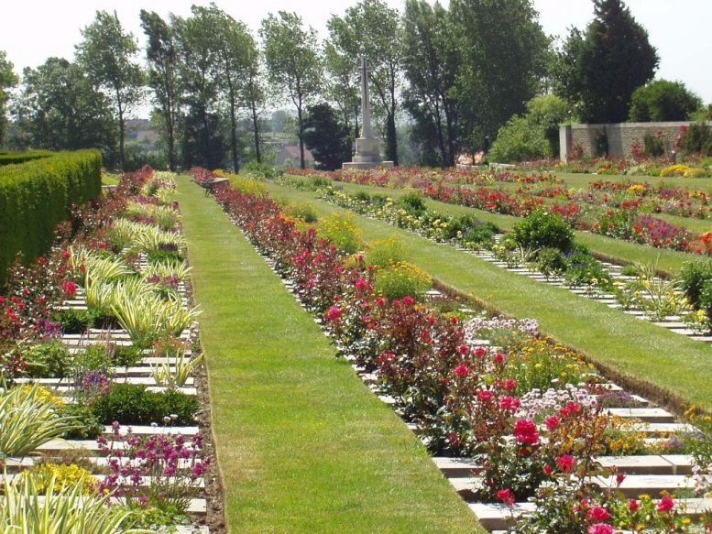

Daisey’s sister, Blanche Sarah Harter married William Clancy Feaviour from Watford. He was living at 8, Hillside Road, Bushey when he enlisted in 1914. He was killed on 6 December 1916 and is commemorated on the Bushey memorial and at St James’ Church.

