Leonard Bysh
Leonard Bysh was born in Bushey in about 1887, the oldest of three children of James and Amelia Bysh. The family made their home in Hoddesdon, Hertfordshire. Leonard emigrated to Australia, where he worked as a labourer in Subiaco, near Perth. He enlisted as Private 897 with the Australian Infantry, 44th Battalion and on 6 June 1916 he embarked with the Machine Gun Section from Fremantle on HMAT Suevic. Later promoted to Sergeant, he was killed in action in Belgium on 4 October 1917 and, having no known grave, he is commemorated on the Menin Gate Memorial, Ypres, Belgium. His brother-in-law, 3012 Driver Walter Gordon Bone, died of illness on 28 October 1918. His parents, James and Amelia Bysh, also emigated to Australia and lived at ‘Broxbourne’, Shaftesbury Road, Burwood, New South Wales.
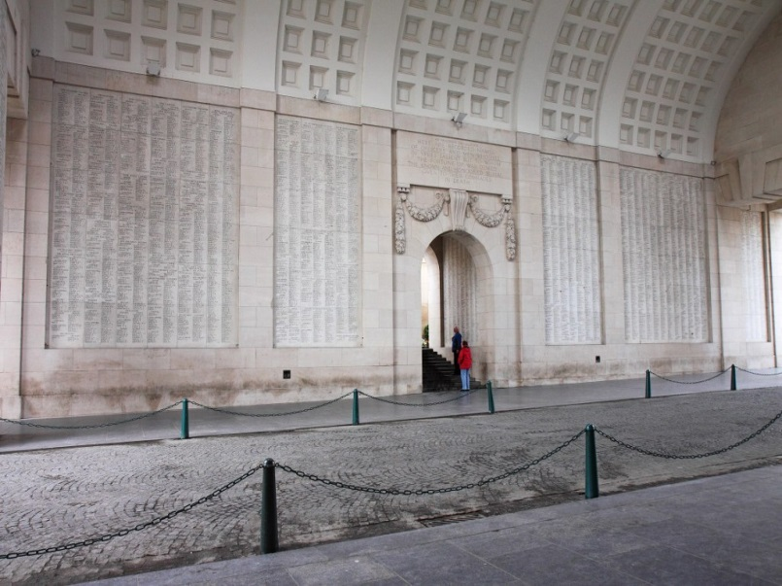
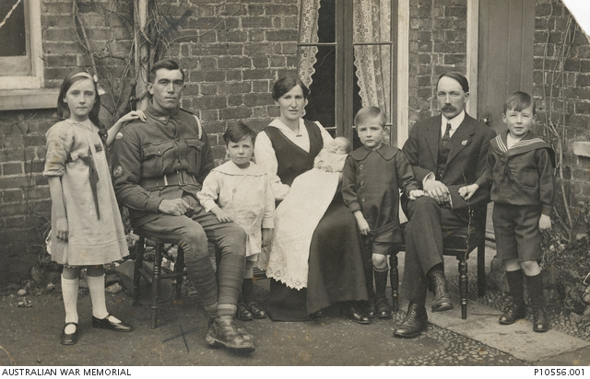

Outdoor portrait of 897 Private (Pte) Leonard Frederick Bysh, 44th Battalion with Dover family members at "Ivanhoe", Lord Street, Hoddesdon, Hertfordshire.

Left to right: Irene Amelia Dover: Pte Bysh; Edwin Thomas Dover; Gertrude Amelia Dover (sister of Pte Bysh) holding Gertrude May Dover (born 1916); William Frederick Dover; James Dover and Leonard James Ralph Dover.

www.awm.gov.au
Acknowledgement: Jonty Wild - Herts at War Project

