Leslie George William Carter
Leslie George William Carter, born in Bushey Heath on 7 July 1896, was the only son of George Carter and Emily Ivory. He was baptised at St Peter’s Church, Bushey Heath on 6 November 1896, when George Carter gave his occupation as a coachman.

At the time of the 1901 census, when Leslie was four, he and his parents were living at ‘Alpha Cottage’, High Road, Bushey Heath with Emily’s parents, Alfred and Elizabeth Ivory. Alfred was employed as a brewer’s drayman and George Carter as a builder’s labourer. Also living in ‘Alpha Cottage’ was 5 year-old Laurie Settie, who was adopted, Elizabeth Ivory and her daughter, Dulcie, also aged 5.

By the time of the 1911 census, Albert Ivory, now an OAP, and Elizabeth had moved to 5 Springfield, Bushey Heath, a four-roomed cottage, together with George and Emily Carter, Leslie, now 14 (referred to as George William in the census) and Laurie, (now with the surname Ivory), aged 15. Leslie was employed as a laundry messenger and Laurie as a nurse girl.

During the war Leslie Carter served with the 10th squadron of the Royal Air Force, Number 16237, Air 79/184, Air Mechanic 2nd Class. His service record in 1915 gives his previous occupation as a Motor Driver and his age as 19. He was killed in action on 1 April 1918 and was buried at Doullens Communal Cemetery Extension No 1, in France, grave VI. G. 55.

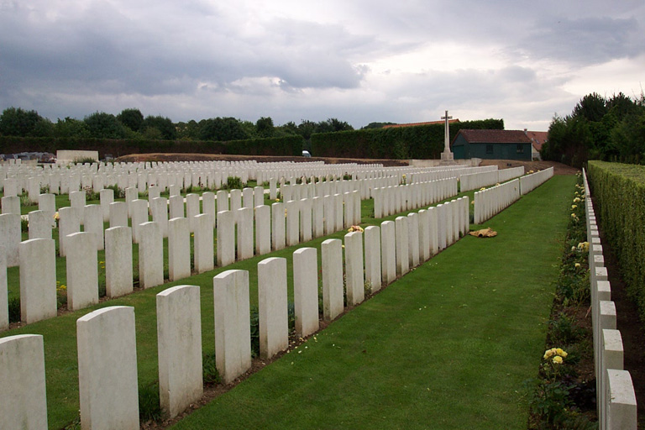

He is commemorated on the Bushey Memorial on Clay Hill, at St James’ Parish Church and at St Peter’s Church, Bushey Heath, where he was baptised.

