Louis Joseph Conquest

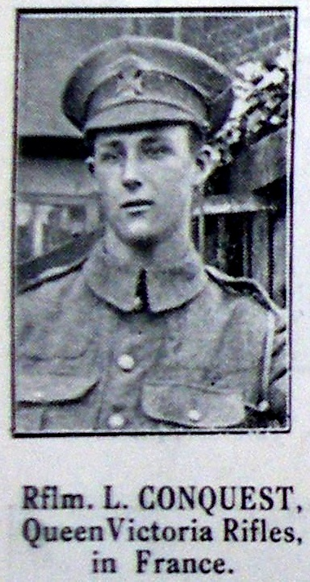

Louis Joseph Conquest, born in 1898, was the son of Joseph Oliver Conquest, a carpenter, and his wife Annie. They lived at 22 Oxhey Street (now part of Oxhey Avenue) but by 1911, when Louis and his younger brother, Albert, were at school, the family had moved to 17, Watford Heath. Louis enlisted as Rifleman 3982 in the London Regiment, 1st/9th Battalion and was killed in action on the first day of the Somme, 1 July 1916, aged 18. His parents subsequently moved back into Oxhey Street, this time to number 37. Louis is remembered with honour on the Thiepval Memorial of the Missing of the Somme. He is commemorated on the memorial at Bushey and Oxhey Methodist Church and at St Matthew’s Church, Oxhey.

Michael Conquest, the owner of Mavis, the wool and craft shop, on Bushey High Street is his nephew.

