Harold Henry Cox
Harold Henry Cox, born in Bushey in 1888, was the son of Henry Thomas Cox and his wife, Priscilla. His father came to Bushey from Islington in the early 1880s to be Herkomer’s fine art printer and later founded H T Cox and Sons, Fine Art Printers, in Melbourne Road. Harold was one of eleven children, four of whom went into the business, which survived until 1970. Harold initially lived with his parents at ‘Lace Cottage’ in the High Street near Melbourne Road. He attended Watford Boys’ Grammar School and, like his father, became a fine art printer.
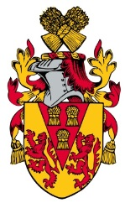
When war broke out he enlisted at Wood Green as Private 47528 with the Royal Fusiliers (City of London Regiment). He served on the Western Front. He died on 14 May 1917, aged 28, and was buried at Etaples Military Cemetery, near Bologne in northern France.
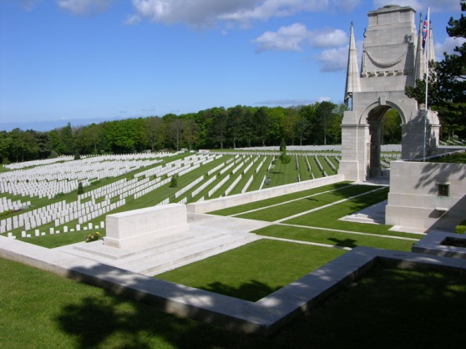
The news of his death in France was published in The Watford Observer :
Private Harold Henry Cox, Royal Fusiliers, son of Mr & Mrs Cox of ‘Solon’, Bushey, who was wounded in France on 23 April, passed away at a military hospital. He was a fine art printer by profession. He had been in the army for about two years. His death was caused by a gun shot wound in the shoulder. Mr and Mrs Cox were only informed on Sunday of their son’s serious condition and they were invited to travel to France to see him. Mr Cox went over on Monday but when he arrived his son was already dead and buried. Private Cox was a native of Bushey, 28 years of age, and besides being a member of the Conservative Club, was an enthusiastic supporter of the Bushey Cricket team.
A memorial notice was also published:
In loving memory of Harold H Cox, son of Mr H T Cox, of ‘Solon’, Bushey (wounded in action in France), who died 14 May 1917, aged 28 years.
Rest well, brave heart, by stream and hill.
Where many a hero’s grave grows green,
You live in hearts that love you still,
You live with Christ in realms unseen.

Watford Observer

Mr and Mrs Cox later moved to ‘Ensor’, 64 High Street, Bushey.
Harold Henry Cox is commemorated on the Bushey Memorial, at St James’ Parish Church and on the family grave in St James’ churchyard.
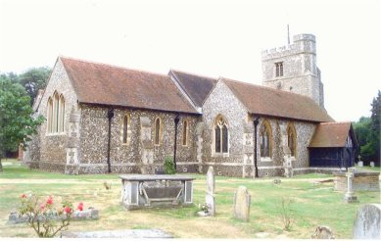
In 2007, on the 90th anniversary of Harold Henry Cox’s death, some of his closest relations met to lay a wreath in his memory at the War Memorial in Bushey after the Remembrance Day service at Bushey Parish Church.

