Harold William Culling

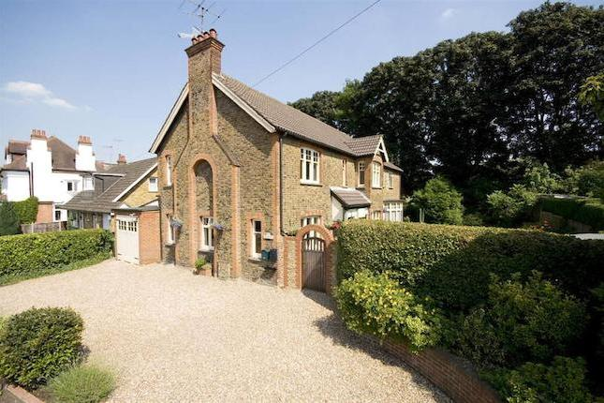
The Shieling, Grange Road

Harold William Culling, born in Willesden, Middlesex in about 1898, was the younger son of James William Henry Culling and Edith Winifred Maude Culling, in a family of three children. His father was a Civil Servant, an Assistant Director of Victualling at the Admiralty. The family lived initially at 57 Connaught Road, Willesden, but by 1911, when the children were at school, they had settled at ‘The Shieling’, Grange Road, Bushey and later in nearby to ‘Rostellan’ in Bushey Grove Road (the section now re-named Woodlands Road).

Harold enlisted and gained a commissioned as Second Lieutenant with the West Riding Regiment and was killed in action on 7 July 1916, aged 19. He is remembered with honour on the Thiepval Memorial to the Missing, Pier & Face 6A & 6B. He is commemorated on the Bushey Memorial, at St James’ Parish Church and at St Paul’s. His elder brother, Private Victor James Culling died of wounds at home on 28 October 1918, aged 23.

