Edward Hedley Cuthbertson
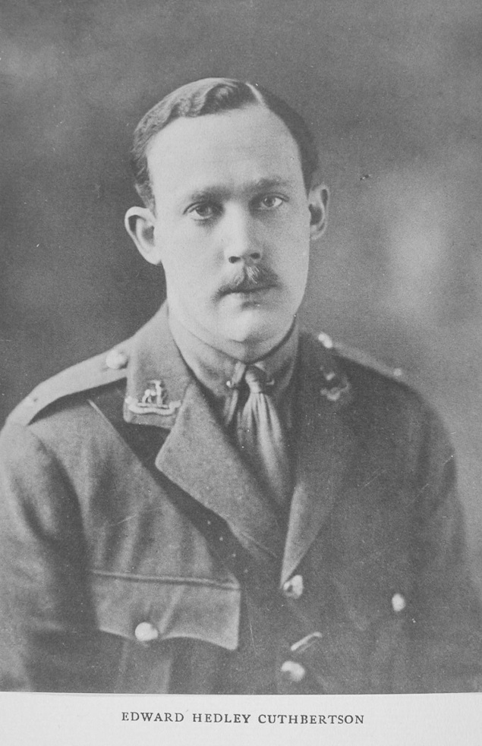

Edward Hedley Cuthbertson was born in Stoke Newington, Middlesex in 1888, the eldest son of Edward Hedley Cuthbertson, a stockbroker, and Alice Munro. While retaining a home near central London, his father also became a significant landowner in Bushey, Hertfordshire. From 1900 the Cuthbertson family lived at Bushey House, where they hosted magnificent garden parties in the grounds.

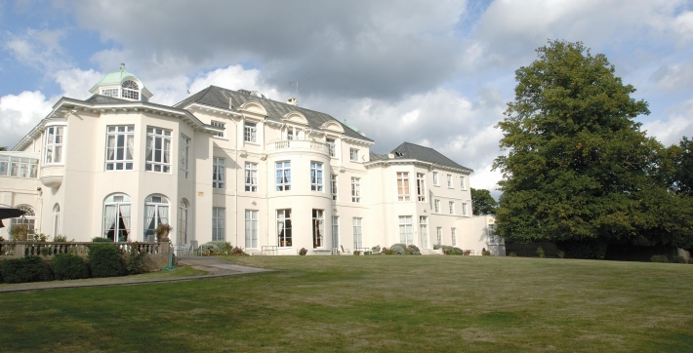

Bushey House (now Bushey House Beaumont)

Edward was educated at Winchester House School in Eastbourne and Malvern College. From there he went on to Clare College, Cambridge, where he gained a ‘blue’ for Association football and played cricket for his university. In 1908 he travelled to New York with his father and younger brother, Hugh, and to Canada in 1910. By then he had begun a career in the City and he became a member of the Stock Exchange. In 1912 he married Mary Constance (Doddie) Williams. The Cuthbertson family left Bushey House shortly after his marriage.

In August 1914, Edward enlisted in the Public Schools Battalion of the Royal Fusiliers and gained a commission as a Lieutenant in the Warwickshire Regiment.

He went to France in March 1915 and was wounded at Ypres a few weeks later. Returning to France, he was invalided home again in July 1916 and after a period of convalescence in England, was sent to Mesopotamia. He died in the British Hospital in Amara on 24 July 1917, aged 28. He was buried in Amara War Cemetery in Iraq and is commemorated on the Bushey Memorial on Clay Hill and on the plaque in St James’ Church, Bushey.

Edward and Mary Cuthbertson had two daughters, Pamela, born in June 1915 and Suzanne in June 1917. Mary re-married after the war in 1920 and she and Francis B Follett had two children.

Hugh Cuthbertson, born in 1891, was also educated at Winchester House School, Eastbourne. He gained a commission as Second Lieutenant in the Royal Field Artillery and was killed in action on 14 April 1918, aged 27. He was buried in Fouquieres Churchyard in northern France and is commemorated with his brother on the Bushey memorial and at St James’ Church.

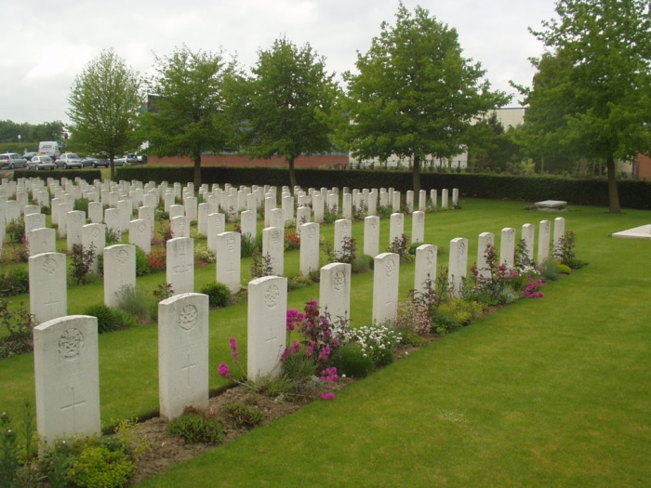
Fouquieres Churchyard, France
Sources: Ancestry.com; CWGC; The Stock Exchange War Memorial 1914-1918.

