Daniel Davey
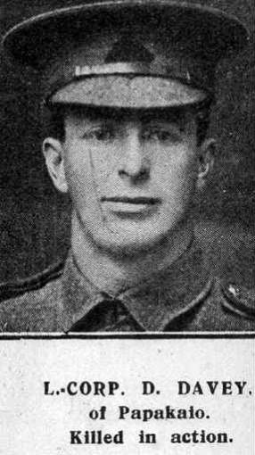
Daniel Davey, born in about 1891, was the son of John and Ellen Davy of Broomfield, Papakaio, Oamaru, Otago, New Zealand. He enlisted in the New Zealand Rifle Brigade, 1st battalion, number 23/113. He embarked from Wellington, New Zealand on 9 October 1915 and arrived in Egypt. The whole of the New Zealand Expeditionary Force was then moved to a training base in England, this being more suitable for troops destined for service in France.
In September 1917 he married Nellie Florence Herne, a member of an established Oxhey family, who lived at 3 Caroline Cottages, Capel Road, Oxhey in Watford. Nellie was aged 24 and worked as a domestic servant. Daniel served as a Lance Corporal on the Western Front and died at Ypres in the Battle of Passchendaele a month after the marriage on 12 October 1917, aged 26. He is remembered with honour at the Tyne Cot Memorial N Z Apse Panel 7.
In the spring of 1919 Florence married again in London and as Mrs Florence Vernon lived at 30A Pinner Road, Oxhey. Daniel Davey is commemorated on the memorial at St Matthew’s Church, Oxhey.
