Sidney Francis Dawes
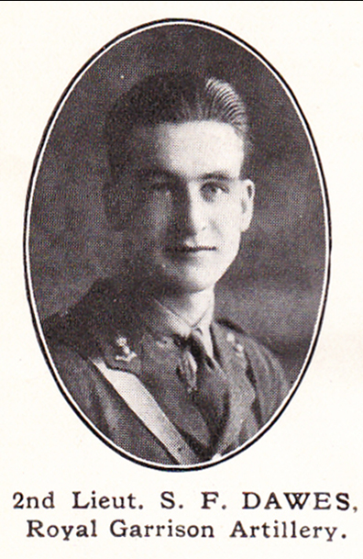
Source: The Fullerian WBGS
Sidney Francis Dawes, born in Clapham in about 1897, was the youngest of the three children of Albert Henry Dawes and his wife Beatrice. His father was a private tutor and the family lived initially in Battersea, but by 1911 they were living at 26 St Albans Road, Watford. Sidney attended Watford Boys’ Grammar School and then obtained a scholarship from there to Christ’s Hospital.
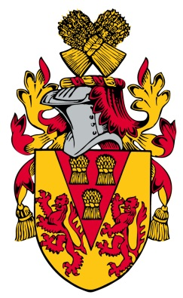
The census of 1911 shows him, aged 12, as a boarder at the school in Horsham. Like John Gray Woolman, who also went from Watford Grammar School to Christ’s Hospital and died in the war, Sidney became a house monitor there. He continued his education at Jesus College, Oxford as a Classical Exhibitioner.
During the war he gained a commission and served as a Second Lieutenant with the Royal Garrison Artillery. He was killed in a German air raid on 9 October 1918, aged 22. He was buried at Busigny Communal Cemetery Extension. His parents moved from Watford to 28 Koh-i-Noor Avenue, Bushey after his death and he is commemorated on their grave in Bushey churchyard..

