George Thomas Deayton
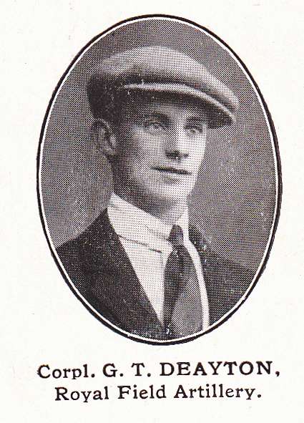
Source: The Fullerian WBGS
George Thomas Deayton, born in Watford in 1887, was the son of Thomas and Mary Deayton of 74 Sutton Road, Watford, the eldest of six children. His father was a railway clerk and George attended Watford Boys’ Grammar School from 1899 until 1902.
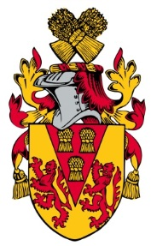
After leaving school, George was employed as a clerk in a brewery. On 30 September 1912 he married Kathleen Gladys Doughty in Pinner and they had two children, Geoffrey and Kenneth. When war broke out George enlisted with the Royal Field Artillery and served as Corporal 233960 on the Western Front. He died of wounds on 10 August 1917, aged 30, and is buried at the Aeroplane Cemetery in Belgium. George is commemorated on the memorial at St Matthew’ Church, Oxhey. Kathleen married again and lived at ‘Hylands’, 59 Oxhey Avenue, Oxhey.

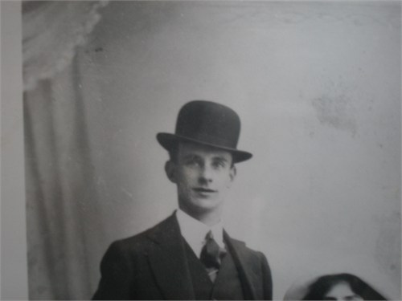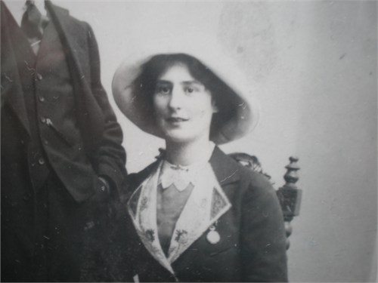

George Deayton and his wife, Kathleen Doughty
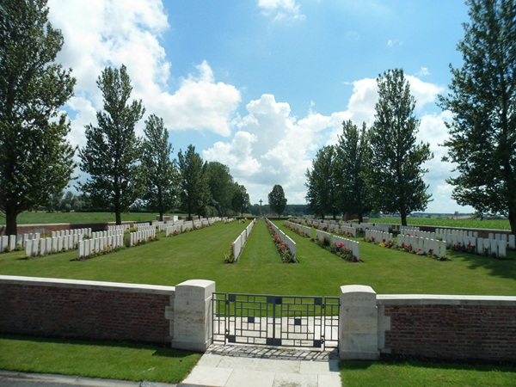
Aeroplane Cemetery, Belgium

