Noel Montagu Charles Dudley

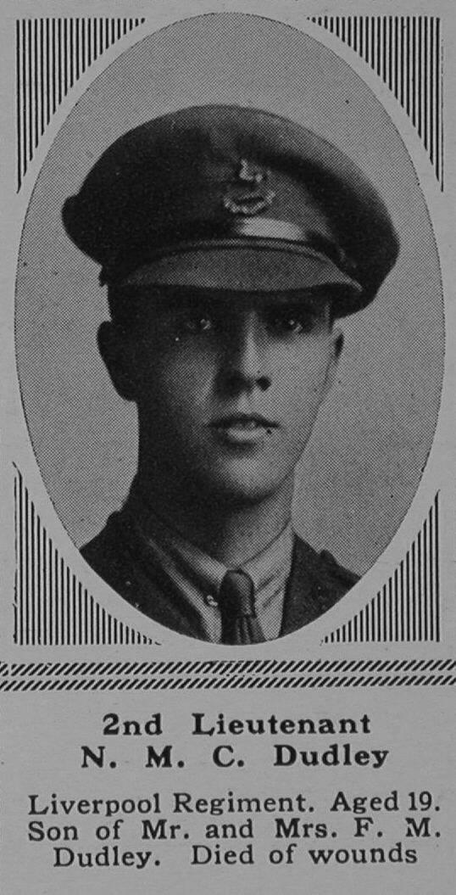

Noel Montagu Charles Dudley was born in Durban, Natal, the elder son of Francis Montagu Dudley and Margaret Dudley. His father was a South African merchant. From 1906 until 1911 he was a pupil at Watford Boys’ Grammar School.
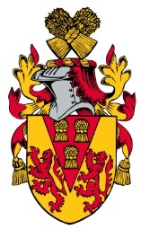
He served as Lieutenant in the 1st/5th Battalion of the King’s (Liverpool) Regiment on the Western Front. In October 1916 The Watford Observer reported:
‘Mr F W Dudley of ‘Wentworth’, The Avenue, Bushey Grove, has received intimation that his son was wounded on Wednesday last. A shell burst quite close to him, wounding him in the thighs and right shoulder, breaking his right arm and taking off part of his right wrist. He had been about three weeks at the Front, fighting practically all the time. He is now in the Duchess of Westminster’s Hospital; and is reported to be making satisfactory progress. He appears to have had a miraculous escape from death’.
Lieutenant Noel Montagu Charles Dudley died from his wounds received on the Somme on 11 October 1916, aged 19.
He lies buried in Etaple Military Cemetery, grave I A 60.
He is commemorated in Bushey on the St James’ and St Paul’s memorials and there is a stained glass window, ‘The Risen Christ’, in his memory in the north aisle of St Matthew’s Church, Oxhey.
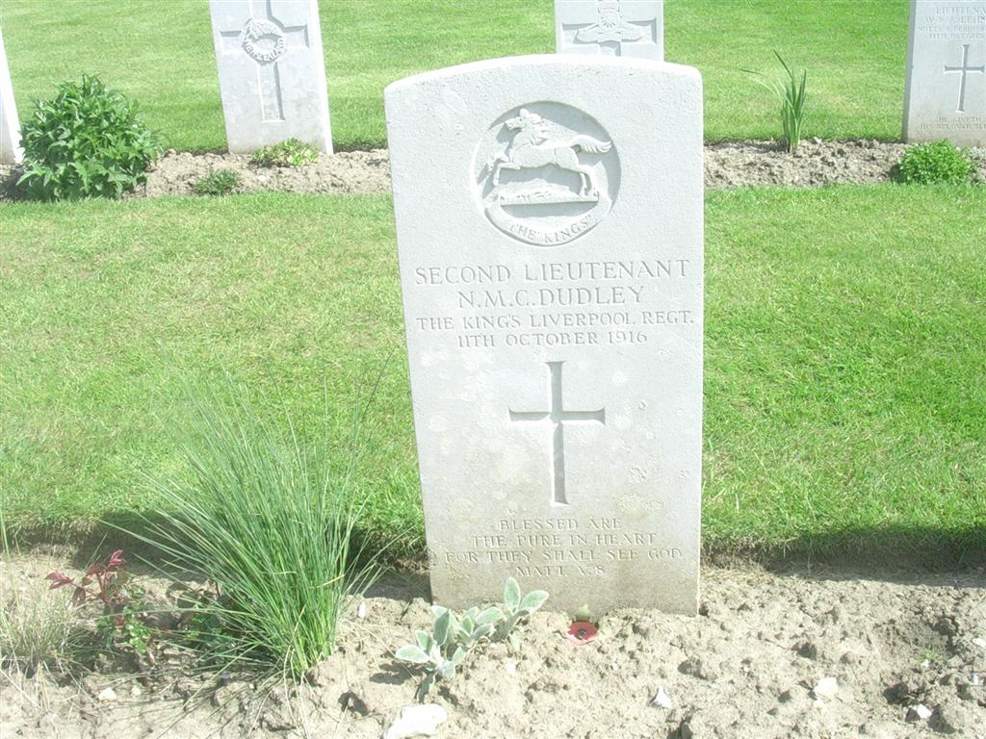
2nd Ltn Dudley’s grave at Etaples Cemetery

