William Thomas George Evans
William Thomas George Evans, born on 16 June 1902 in Oxhey and baptised at St Matthew’s Church on 25 July 1902, was the son of David and Avis Evans. In 1911 they were living ay 119 Paddock Terrace, Lower Paddock Road but later moved to 6 Caroline Cottages, Capel Road. William served as a Boy 2nd Class J/92152 on HMS Ganges II, the Royal Navy’s boys’ training ship in Shotley. He died of disease, aged 16, on 28 January 1919. He is remembered with honour and buried in the naval graveyard at St Mary’s Church, Shotley near Harwich and he is commemorated at St Matthew’s Church, Oxhey. His father, David Evans, who died in Glasgow on 17 November 1918, is also commemorated at St Matthew’s Church.
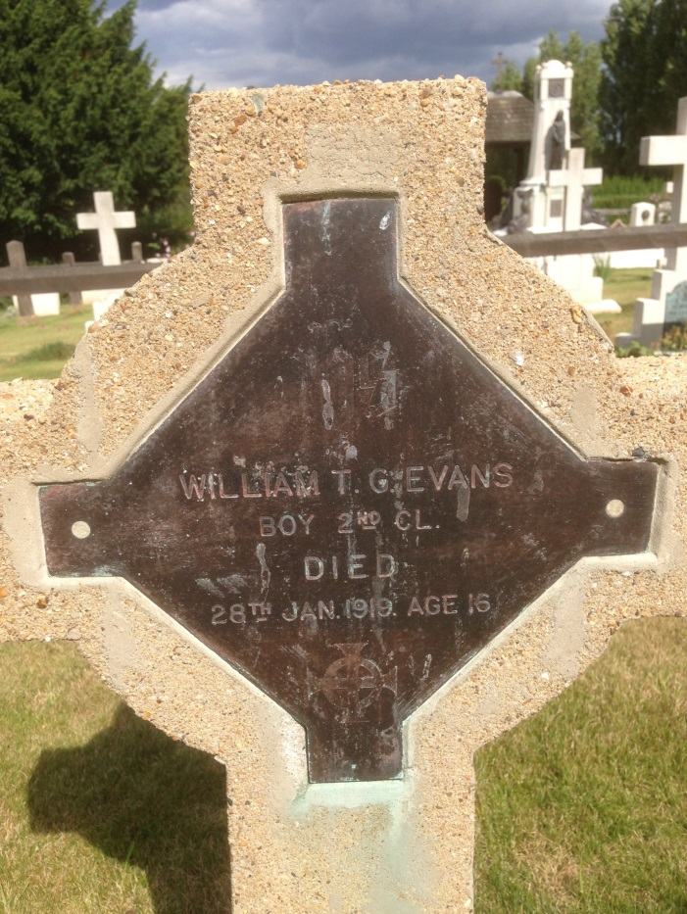
Grave marker for William T G Evans, aged 16
Photographed by Roz Donnelly 13 August 2014

