Archibald Onslow Farmer
Archibald Onslow Farmer, born in Barnet, Hertfordshire in 1893, was the eldest son of Archibald Sidney Farmer, an accountant, and his wife, Maude Agnes Farmer. He grew up in Arkley, near Barnet, but by 1911 the family had moved to Bushey and were living at ‘St Austell’, 70 Bushey Grove Road. Archibald was 18 and a clerk at the Stock Exchange.
He enlisted in the Hertfordshire Yeomanry and, while serving in Egypt, won the 100 yards race at the Territorial Sports centre in Cairo. A newspaper report (undated) stated, ‘The final of the 100 yards produced the best struggle of the day. Trooper Farmer of the Herts Yeomanry broke the tape first by half a yard. The winner’s time was good considering the state of the track. He is a prominent South of England handicap runner’.
Near the end of the war Archibald joined the Royal Air Force. He became a Second Lieutenant in the Training Squadron and died on 30 May 1918. He was buried at Narborough (All Saints) Churchyard in Leicestershire and is commemorated on the Bushey Memorial and at St Paul’s Church, Bushey.

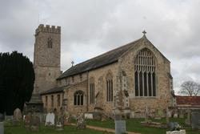
All Saints, Narborough

