William Edward Field
William Edward Field, born in 1894 in Bushey, was the youngest son of Edward and Emma Eliza Field of 66 School Lane, Bushey. His father was a baker and confectioner with a business on Clay Hill and his mother worked as a laundress. William was one of four children, two of whom did not survive to adulthood. At the time of the 1911 census, William was sixteen and was employed as an assistant grocer, while his sister, Sophie, who was a year older, worked as a domestic servant.

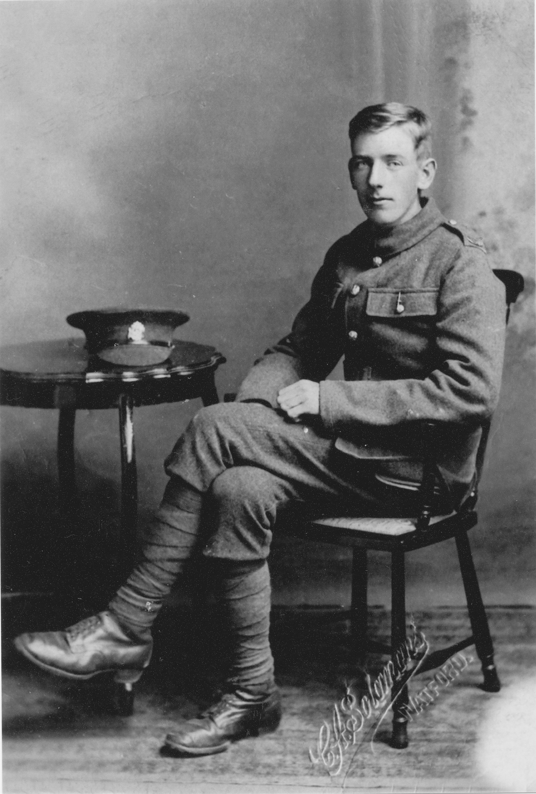
When war broke out, William enlisted at Watford initially as Private 25933 in the Bedfordshire Regiment, transferring later as Private 202327 to the 17th Battalion of the Welsh Fusiliers. He had a limp and so served in France and Flanders as a stretcher- bearer. He was killed in action on 27 April 1918, aged 24. He is remembered with honour at Bouzincourt Communal Cemetery Extension in France. He is commemorated on the Bushey Memorial, at St James’ Church and at St Peter’s Church, Bushey Heath, where an altar cross was given in his memory.

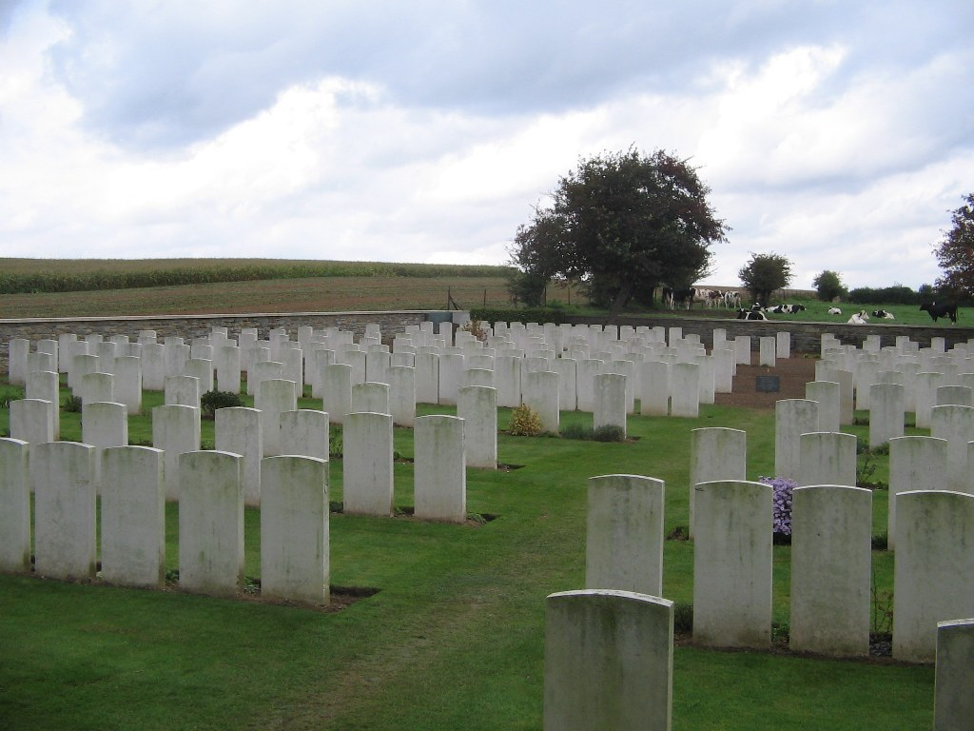
Bouzincourt Communal Cemetery Extension in France.

