Frederick James Gadsden
Frederick James Gadsden, born in Wilden, Bedfordshire, in 1886, was the son of Ellen Louise Gadsden and an unknown partner. Frederick lived with his mother, his younger sister, Kate, and his grandparents in Wilden, Bedfordshire, In 1891 is mother married Walter Giddings but Frederick and Kate retained the name Gadsden. His mother had eight more children.
Frederick was employed as a farm labourer in Wilden and on 15 January 1912 he married Elizabeth Rose Wells, who was born in Bushey, a member of an established Bushey family. His enlistment records show that in November 1914, he was living at 51, Clay Lane, Bushey, He and his wife had 2 children: Rosina, born on 20 February 1914 in Bushey Heath and Violet, born on 20 May 1917 in Watford.
He volunteered in November 1914, and served as Private 18073, "D" Coy. 2nd Battalion, Bedfordshire Regiment. After completing his training, he rendered valuable service whilst employed as Lewis Gun Instructor at Felixstowe until 1916, when he was drafted to France. There he took part in strenuous fighting on the Somme front and at Vimy Ridge and Arras. Invalided home later on account of ill-health, he was discharged in April 1918, and unhappily died in Bushey Heath on October 30th, 1918, from an illness contracted on military service, aged 32. He was entitled to the General Service and Victory Medals.
He was buried in the cemetery at Wilden (St Nicholas) Churchyard in Bedfordshire, Z2546/B and is commemorated at St Peter’s Church, Bushey Heath.
His wife married George A Lovell in 1920 and they lived in Wilden.
[From National Roll of the Great War Section XII - Bedford & Northampton

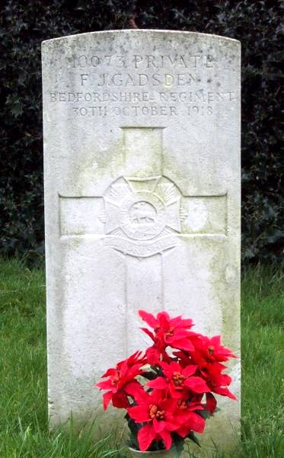
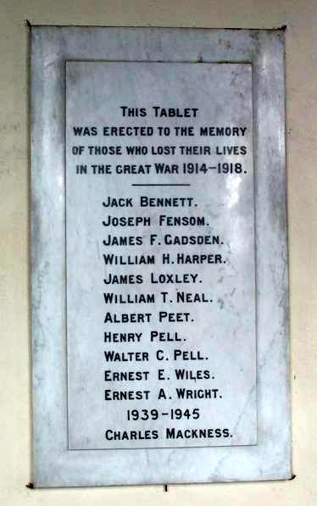

WILDEN - Roll of Honour
World War 1 & 2 - Roll of Honour with detailed information
Compiled and copyright © 2001 John Page

