Henry Burgh Gair

Henry Burgh Gair, born in 1882 in Toxteth Park, Liverpool, was the eldest of three children of Walter Burgh Gair and his wife Elizabeth. His father was a banker and in 1907 a Director of the Great Central Railway, with a railway engine named after him. Henry spent his early years in Toxteth Park with his two sisters, where his parents employed four servants. By 1911 the family had moved south and were living at Kestrel Grove, Bushey Heath, a large family house, which is now a Nursing Home. At that time, Bushey Heath was a pleasant and prestigious place to own or rent a country house within convenient travelling distance from London. Henry lived there with his parents and was employed as a bank clerk as the first stage in a banking career.
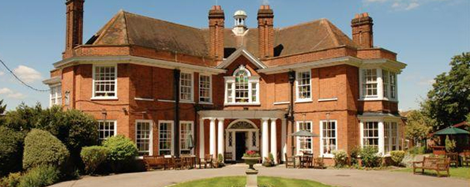
Kestrel Grove
In the spring of 1911 he married Mary Dorothea Moultrie Coleridge, the daughter of Ernest Hartley Coleridge (1846 – 1920), a British literary scholar and poet. He was son of Derwent Coleridge and grandson of Samuel Taylor Coleridge. He completed scholarly work on his grandfather’s manuscripts, being the last of the Coleridges involved in their editing. He also took part in the campaign to buy the Coleridge Cottage in Nether Stowey for the nation. Mary Coleridge was 24 when she married Henry Burgh Gair and was a High School Mistress in Croydon.
During the war Henry enlisted with the Dorsetshire Regiment and gained a commission as a Second Lieutenant. He died on 15 May 1918, aged 35, of wounds received near Bretencourt two days earlier. He was buried at Bagneux British Cemetery, Gezaincourt in France. His death was announced in The Times and he is commemorated on the Bushey Memorial. After his death, his wife moved to 110, Goldhurst Terrace, Hampstead. She never re-married and died in London in December 1941.
