John Henry Gare
John Henry Gare, B.A. (Oxon), born on 3 February 1891, was the son of Henry Vernon Gare and his wife, Kate Alice, of Steeple Aston, Oxfordshire. On leaving Oxford High School in 1909 he proceeded to the University, and was for four years a member of St. Edmund Hall, graduating with Honours in Modern History. During his residence at University he rowed for his college for four years, and was considered the best oarsman during this time. He also represented the college at Cricket and Football.
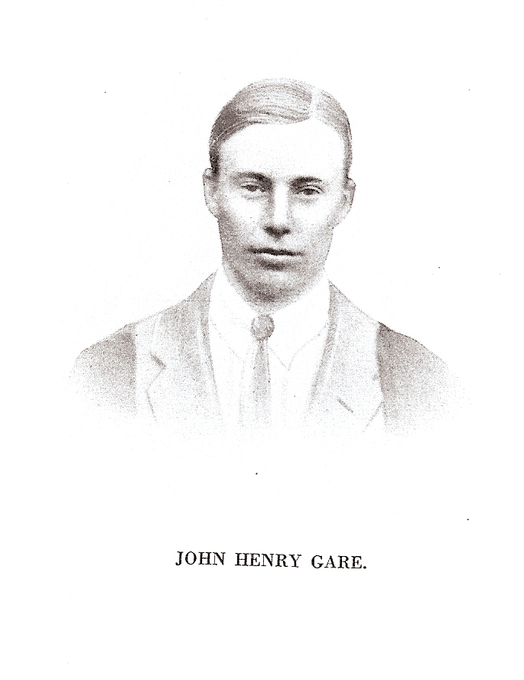
In September, 1913, he joined the staff at Bushey as Geography Master, in succession to Mr. Wetherill, and became Housemaster of "B" House in September, 1915. He took an active part in all the games of his House and of the School. He joined the Artists' Rifles on 21 September, 1916, and was for some time attached to G.H.Q. in France, where he became a sergeant. On the death of his only brother, he renounced his claim to the commission for which he had been waiting, but he was due to return to England to train for it about the time of his death. In November, 1917, he was stationed at Passchendaele and during the next month he was moved to Cambrai. On 30 December he was reported missing, and his death was I afterwards certified by the War Office. He is commemorated at Thiepval. At his death he was 26 years of age.
From his school and college comes the same tribute to his quiet and unassuming character, his earnestness in all he undertook, and his popularity with all who came in contact with him. He will long be remembered at Bushey, both in House and School, as a splendid type of real strong British manhood. He endeared himself alike to boys and men, and by his genial and kindly disposition as well as by his strong sense of duty, he was an example which all would do well to follow. But when all is said, to have known him best was to have known him in his home life, where he was a "son in a thousand."
Service number 762402 Artists’ Rifles
He is commemorated on the Bushey memorial.

