David Angus Gibbs
David Angus Gibbs was born in 1898 in Chelmsford, Essex, the eldest son of David Cecil Gibbs and Mary Elizabeth Hart. David and his younger brothers, Geoffrey Maxwell, born on 1901, and Walter Haliburton, born 1904 initially lived at ‘Vineyards’, Great Baddow, Essex. His father was a soap and chemical manufacturer and the family employed five servants.
By 1911 the family had moved to Hertfordshire to ‘The Wintons’, The Rutts, Bushey Heath. At that time David was 12 and he and Geoffrey were pupils at The Wick, Furze Hill, a private boarding school in Hove, Sussex. Their father, who was considerably older than his mother, died in 1912, aged 61.
David enlisted with the Rifle Brigade and gained a commission. He became a Second Lieutenant and was killed in action on 24 March 1918, aged 20. He is commemorated at the Pozieres Memorial on the Somme. His name is on the Bushey Memorial and a stained glass window given in his memory is in the St George’s Chapel at St Peter’s Church Bushey Heath.
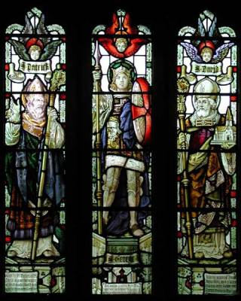  St Patrick St George St David  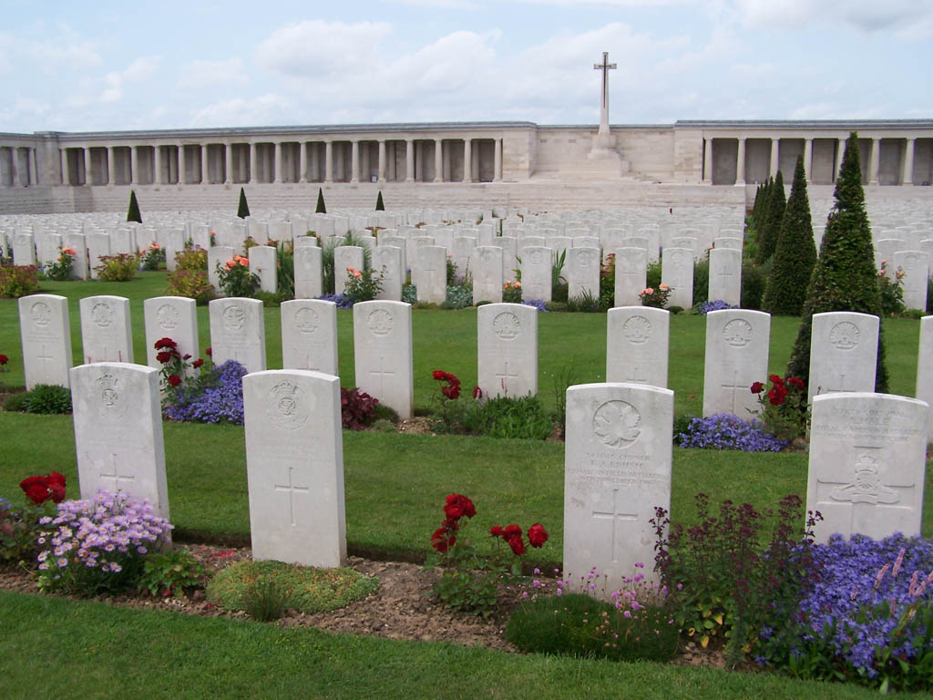 | Patrick - given by mothers  George- given by comrades  David - in memory of David Angus Gibbs aged 19. Somme 1918

