John Clifton Goadby
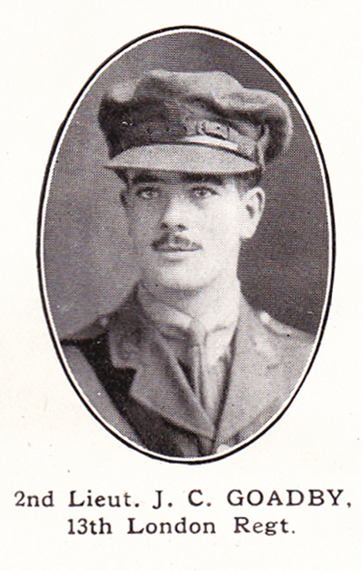
John Clifton Goadby, born in 1898 in Highgate, Middlesex, was the eldest son of John Stubbins Goadby and Mary Monk. The family lived initially in Highgate before moving to Hertfordshire, where a second son, Hugh Clifton Goadby, was born in 1899. John Stubbins Goadby was a land and estate surveyor, working for the Estate & Valuation Department of the London County Council.
The family moved first to Marlborough Road, Watford before settling at ‘Ashcroft’, Bushey Hall Road. John attended Watford Boys’ Grammar School from 1906 until 1911.
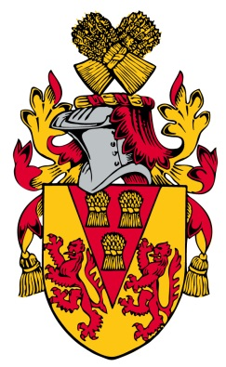
He enlisted with the London Regiment and gained a commission. He served as a Second Lieutenant on the Western Front and was killed in action on 20 August 1918. He was buried at the H A C Cemetery, Ecoust-St Mein in France, grave Sp. Mem. B. 11. and is commemorated on the Bushey Memorial, at St James’ Parish Church and at St Paul’s Church, Bushey.
His brother, Hugh, enlisted as a Private with the London Regiment when he was 18 and survived the war.
