Joseph Goodman
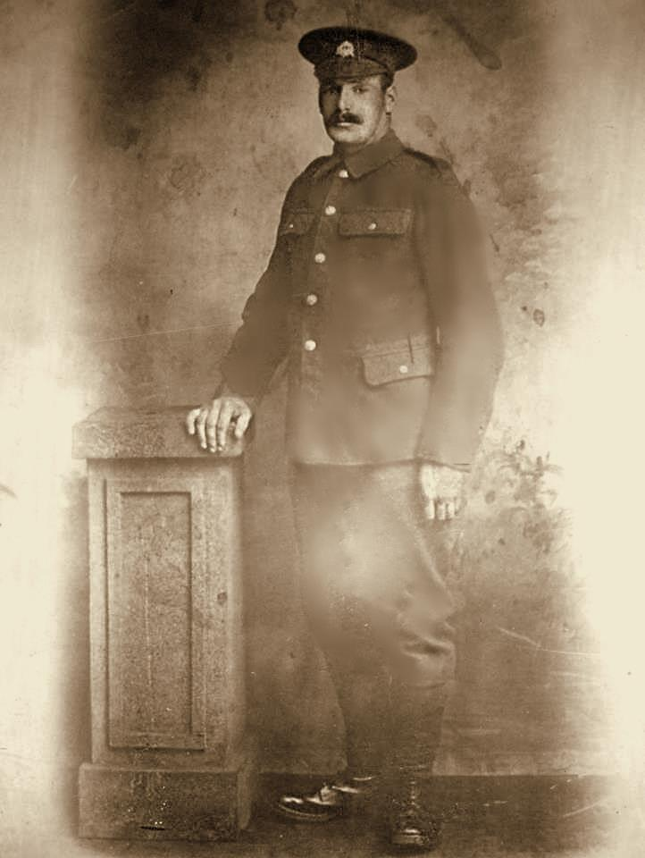
Joseph Goodman, born at Eastbury Cottages, Watford on the 2 April 1887, was the son of George and Sarah Goodman of Bourne End Lane, Boxmoor, Herts. Joseph was working as a gamekeeper when he married Jane Trowles, the eldest daughter of George Isaac Trowles from Watford, on the 12 April 1909. They had four children Ethel (b. 1910), Joseph (b. 1913), Lillian (b. 1914) and Dorothy (b. 1915). In 1911 they were living with his parents at 122 New Road, Croxley Green. Joseph was by now working in the same occupation as his father, labouring on a farm as a ploughman.
On 2nd June 1915, Joseph enlisted at Watford in the Bedfordshire Regiment. He was living at 12 Vale Road, Bushey, Hertfordshire at the time, the home of Jane’s father, George Trowles. Joseph was given the service number 20846 and posted into the 4th battalion. It is thought he transferred to the Loyal North Lancashire Regiment on 14th December 1916, initially joining the 13th battalion, his new service number being 35070. Joseph was then posted to 1st battalion and sent to France. He was later transferred in the 9th battalion, Loyal North Lancashire Regiment. They were in 74th Brigade, 25th Division.
On 11th August 1917, Joseph was killed in action. Following on from the Battle of Pilkem (a phase of the Third Battles of Ypres), the 74th Brigade were tasked to renew the attack on Westhoek, which had been held up so far. The Brigade successfully took their objective, but sustained very heavy casualties in the process, one of which was Private Joseph Goodman. Joseph was awarded the British War and Victory medals. He is remembered with honour on the Menin Gate Memorial.
On 11 December 1917 his wife received a payment of £3/6/- owed from his pay & allowances. A war gratuity of £9/10/- was also paid to his wife on 11 March 1920. Rank: Private. Service No: 35070. Date of Death: 11/08/1917. Age: 33. Regiment/Service: The Loyal North Lancashire Regiment, 9th Bn. Caz –
He is not commemorated on a Bushey memorial.
Source: http://www.wartimememoriesproject.com/greatwar/allied/bedfordshireregt-gw.php#sthash.1z5qkRhC.dpuf
