Lionel Smart Grove
Lionel Smart Grove, born in Watford in 1897, was the only son of Walter and Elizabeth A Grove, who had four children. Lionel was the only one who survived. At the time of the 1901 census, the family was living at 66 Gladstone Road, Watford. Lionel was four and had a younger sister, Gladys, who was just a year old. Walter Grove was an auctioneer. By 1911 the family had moved to 133 Lower Paddock Road, Oxhey. Walter now gave his occupation as an estate agent and Lionel, aged 15, was a pupil at Watford Boys’ Grammar School.
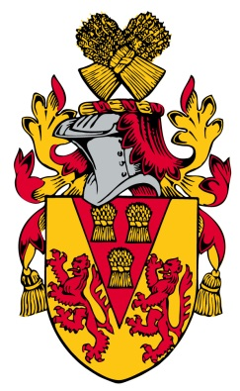
Lionel enlisted as Private 22034 in Holborn, joining the 15th battalion of the Royal Welsh Regiment. He served in France and Flanders and was killed in action on 8 May 1916. He is remembered with honour on the Loos Memorial in France, panel 50 -52. He is commemorated on the memorial at St Matthew’s Church, Oxhey, where his name appears as GROVES, L.
