William John Hallimond
William John Hallimond, born on 9 May 1884, was the only son of John Greener Hallimond and Annie Foggitt. His parents initially lived in Durham, where his father was a coke, coal and iron merchant. William’s sister, Mabel, was born there in 1879 and the family employed 2 servants.
Shortly after Mabel was born, the family moved to Hertfordshire, and William’s birth was registered in the Watford district in May 1884. At around that time his father became involved with the West London Mission, a key Methodist organisation. He became a clergyman, eventually qualifying as a Doctor of Divinity. The 1891 census shows Annie, Mabel and William at 9 Villiers Road, Oxhey ‘living on their own means’. John Hallimond was not present and may already have gone to America, for his family emigrated there the following year, when William was 8 years old.
In 1900, when William was 16, the family was resident in Montclair Town, Essex, New Jersey but by1901, they had moved to New York. His father was now involved with The Bowery Mission, a rescue mission located in the Bowery neighborhood of Manhattan, New York City. It provides food, shelter, medical services and employment assistance to poor homeless men. Supervision of the Mission went to John Greener Hallimond, who introduced many innovative services, such as a home for women in Brooklyn, an employment agency and a breadline, which began in 1902.
William qualified as an engineer and may possibly have been a student at Princeton University in New Jersey. By 1910 he had moved on to Canada and it was there that he enlisted as a machine gunner in the Canadian Infantry.
At the time of enlistment in the Canadian Army he listed his occupation as ‘Civil Engineer’ and his father's address as 407, 8th Avenue, Belmar, New Jersey". An address in The Bowery, New York City, was scratched out. On enlistment in the Canadian Overseas Expeditionary Force on September 22, 1914 William’s height was given as 5ft 8, he had dark hair and blue eyes and his religion given as Church of England. His service number was 7978, 2nd Battalion, Canadian Infantry (Eastern Ontario Regiment). He was killed on April 22, 1915, aged 31, in Belgium, where the first German gas attack took place, and is commemorated on the Menin Gate (Ypres) Memorial to the Missing.
Although he had not lived in England since he was a boy, a connection must have been maintained with Oxhey, where he was born, and his name was placed on the memorial at St Matthew’s Church, Oxhey.
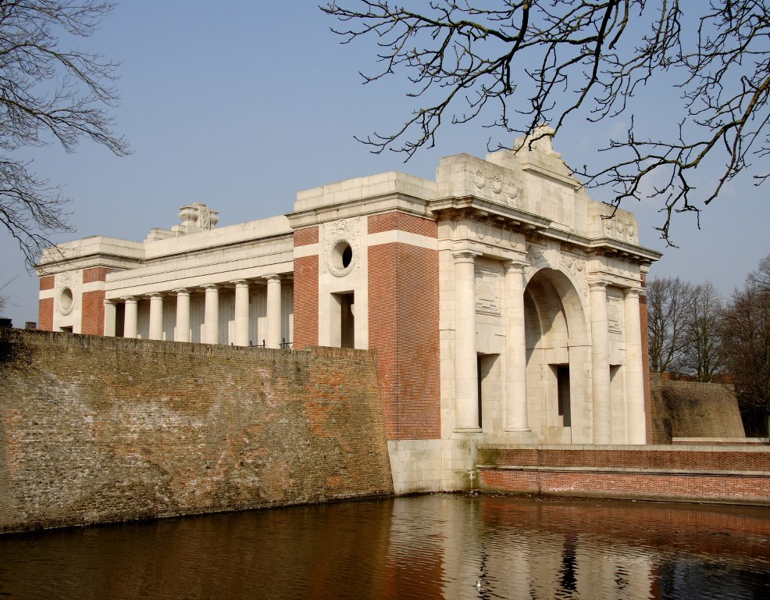

The Menin Gate

