**Frederick Hart**

Frederick Hart, born in Bushey in 1892, was the son of William and Emily Hart of Hamper Mill Cottages. His father was a paper maker at Hamper Mill. Frederick was one of six children. When war broke out he enlisted in Bedford with the Bedford Regiment, later transferring to the Essex Regiment, number 37167. He served in the Egyptian theatre of war and was killed in action in Palestine on 25 November 1917, aged 26, grave/memorial ref L32. He is remembered with honour at Ramleh War Cemetery in Palestine. His parents moved to 2 Garden Terrace, Watford Heath after his death and he is commemorated with his brother, William Hart, on the memorial at St Matthew’s Church, Oxhey.

[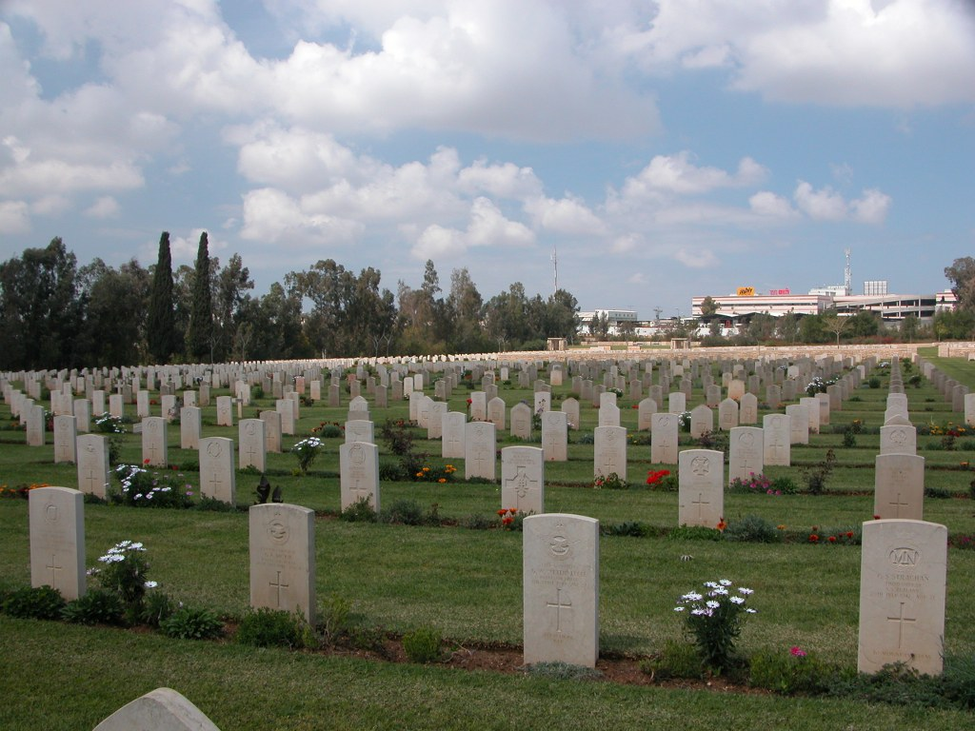](http://www.cwgc.org/dbImage.ashx?id=2474)