**Sidney William Hinton**

Sidney William Hinton was born in Watford in 1893, the fourth in a family of five children born to Charles Hinton, a house painter, and Fanny Hinton. The family lived at 12 Vale Road, Bushey. Sidney was 17 in 1911 and was working as an assistant for a mineral water manufacturer. The family moved to 31 Vale Road during the war. Sidney enlisted in Watford as Private 201254 with the Bedfordshire Regiment, 7th Battalion. He died of wounds on 1 December 1917 and was buried at Dozinghem Military Cemetery in Belgium, grave reference XIV. F. 21. He is commemorated on the Bushey Memorial, at St James’ Parish Church and at St Paul’s in Bushey.

[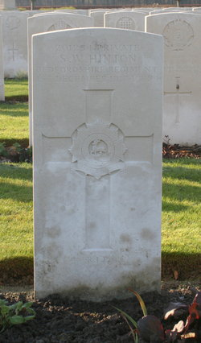](http://www.findagrave.com/cgi-bin/fg.cgi?page=pv&GRid=12518258&PIpi=86285765)