Ronald Morley Hooper
Ronald Morley Hooper, M.A. (Oxon), was born on 4 March 1878, the son of the late Rev. John Henry Hooper, of Stratford-on-Avon, Minister in the Wesleyan Church, and his wife, Jane. He entered Kingswood School, Bath, in July, 1888, and left in June, 1896, to go to Worcester College, Oxford, where he had obtained an open scholarship in mathematics. He gained a First Class in Moderations, and a Second Class in the Final Honours Mathematical School. For the next three years he was Mathematical Master at Daventry Grammar School. From there he joined the staff at Bushey in January, 1904, and in 1909 he became Housemaster of "Knight's."
In December, 1915, he took up a commission in the R.G.A., and after training at Lydd and elsewhere, he was gazetted as Second Lieutenant in June, 1916. Proceeding with his battery he was soon in action, and was ultimately slightly wounded and gassed. In July, 1917, he was granted long leave, and was in England till Christmas, visiting the School on two occasions. He rejoined his battery early in 1918, and was killed instantaneously by a shell on 21 March. He was buried at Lebucquiere Communal Cemetery Extension, east of Bapaume.
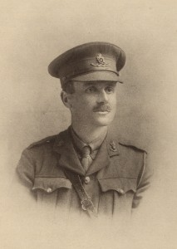

As a Housemaster he will be affectionately remembered by several generations of boys, to many of whom he was "closer than a brother." He never had the conventional outlook of the ordinary schoolmaster. He was essentially a man of peace, a lover of books, and a student, with wide interests beyond his subject, especially in the domain of English literature, where his favourites were Ruskin and Blake. At the same time he was no mean botanist, a musician of parts, and a man whose hobbies were as varied as they were original. All these interests he would share with his House, in whose companionship he delighted.
He is commemorated on the Bushey memorial and on the memorial at Bushey and Oxhey Methodist Church.

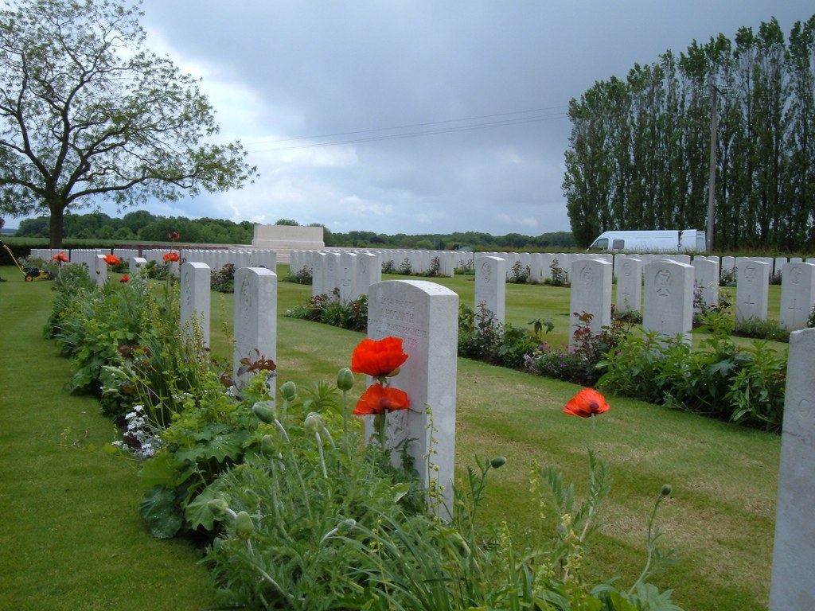
Lebucquiere Communal Cemetery Extension, east of Bapaume, France

