Arthur David Ibbott
Arthur David Ibbott, the eldest son of Arthur Pearson Ibbott and his wife Victoria, was born in Bethnal Green, Middlesex, in 1891, the second in a family of five children. His father was initially a railway clerk and the family lived at a number of addresses in Middlesex before moving to Hertfordshire in about 1900. They settled at ‘Osborne Villa’, 57, Chalk Hill, Oxhey, where their youngest child was born.
Arthur Pearson Ibbott was now a secretary to a public company and by 1911 he had progressed further and was a secretary and accountant to an investment company and the family employed a ‘lady help’. All his sons were educated at Watford Boys’ Grammar School.
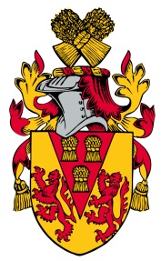
In 1911 Arthur David Ibbott was employed as a commercial clerk in an investment company, his elder sister was an art student and two of his younger brothers were still at school.
When war broke out he enlisted in Watford as a Private with the Bedfordshire Regiment, transferring later to the Loyal North Lancashire Regiment, 9th Battalion as Private 26046. He served on the Western Front and was presumed dead on 3 September 1916, aged 25. He is commemorated on the Thiepval Memorial to the Missing of the Somme and on the memorial at St Matthew’s Church, Oxhey. His name is also one of five servicemen on a small stone memorial plaque belonging to Paddock Road Baptist Chapel, Oxhey.
His parents later moved to ‘Ivinghoe’, Sherwoods Road, Watford Heath.
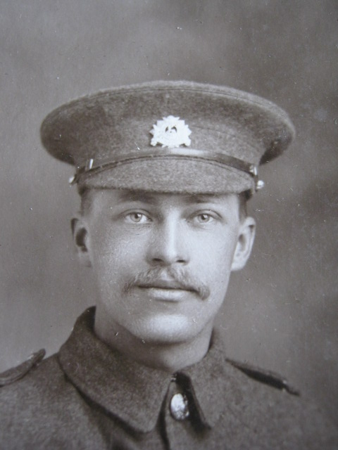
Arthur David Ibbott

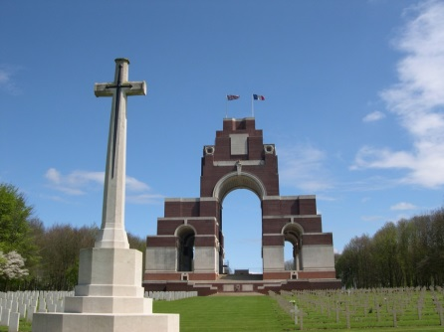
Thiepval Memorial to the Missing of the Somme

