Bertram Charles Ibbott
Bertram Charles Ibbott, the son of Arthur Pearson Ibbott and his wife Victoria, was born in Dalston, Middlesex in 1896, the fourth in a family of five children. His father was initially a railway clerk and the family lived at a number of addresses in Middlesex before moving to Hertfordshire in about 1900. They settled at ‘Osborne Villa’, 57, Chalk Hill, Oxhey, where their youngest child was born.
Arthur Pearson Ibbott was now a secretary to a public company and by 1911 he had progressed further and was a secretary and accountant to an investment company and the family employed a ‘lady help’. At that time, Bertram was a pupil at Watford Boys’ Grammar School.
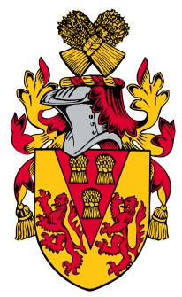
He enlisted in Watford as Private 85380 with the Machine Gun Corps. He served on the Western Front and died of wounds on 16 July 1917, aged 21. He was buried at the Beehive Cemetery, Willerval in northern France. The cemetery owes its name to a German machine gun emplacement known to the British troops as "The Beehive". It was made by fighting units after the occupation of Willerval in the Battles of Arras, 1917. At home, his name is also one of five servicemen on a small stone memorial plaque belonging to Paddock Road Baptist Chapel, Oxhey.
His parents later moved to ‘Ivinghoe’, Sherwoods Road, Watford Heath.

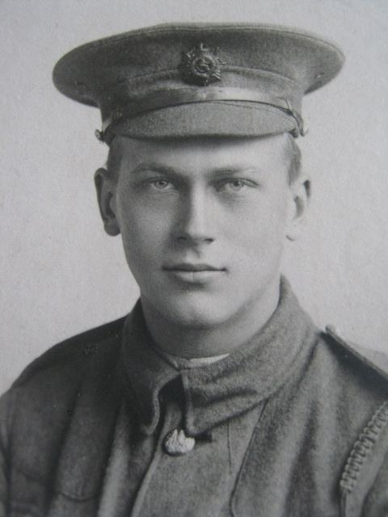

Bertram Charles Ibbott

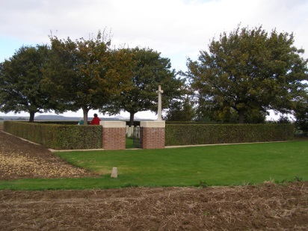

The Beehive Cemetery, Willerval in northern France.

