William James Ingram

William James Ingram was born in about 1888 in Weston Turville, Buckinghamshire, the eldest son of William and Eliza Ingram. His father was a duck breeder and a publican at The Crown, West End, Weston Turville. In 1900, when William was about 12, his father died, leaving his mother widowed at the age of 36. The 1901 census shows Eliza as a poultry farmer and innkeeper at The Crown, with three children, William, Maud and Peter Charles Ingram. Edward Pearson, a boarder who was employed as a greengrocer, was living with them. In about 1903 Eliza married him and they had a daughter named Queenie. By 1911 William and Maud had left home, while Edward, Eliza, Queenie and Peter had moved to Hertfordshire to settle at 116 School Lane, Bushey. Peter was 17 and was working as a greengrocer. Peter served as a Private with the Royal Field Artillery and was away from home in 1918 at the time the Absentee Voters’ Lists were compiled.
The service record of William James Ingram shows that before the war he was a Sergeant in the Metropolitan Police and then emigrated to Australia. The Australian Archive indicates that he enlisted on 26th August 1914 with the 1st battalion of the Australian Infantry and served as Sergeant 907. His mother, Mrs E Pearson of 116, School Lane, Merry Hill, Bushey, was informed that on 13 December 1915 he had died of wounds from injuries received in action in Gallipoli. He is buried in Pieta Military Cemetery in Malta. The Service Record includes a letter sent from his mother’s home address in December 1915 asking for details of the circumstances of his death. He is commemorated on the Bushey Memorial and on the memorial in Weston Turville, near his childhood home.
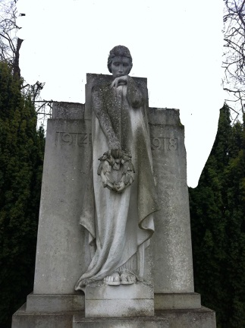
Bushey Memorial
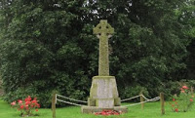
Weston Turville Memorial
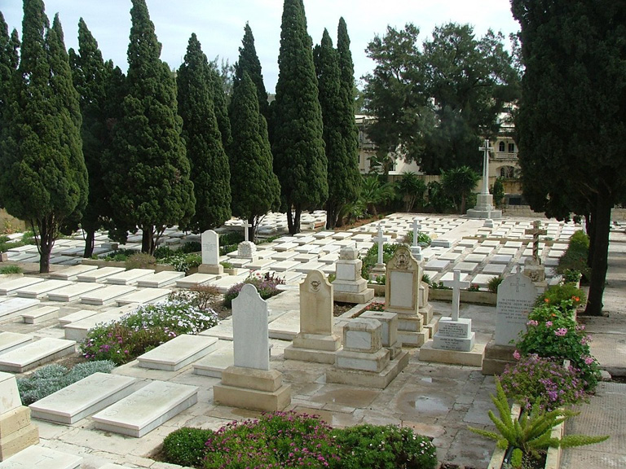
Pieta Military Cemetery, Malta

