Edmund Johnson

Edmund Johnson was born in Hampstead, London, in about 1888, the only son of Edmund Littler Johnson. His grandfather, James H Johnson, was a coal proprietor and iron master in Lancashire, who employed 1,500 men. His father, a colliery manager by the age of 23, moved to London, where he became a metal merchant, trading in tin plate. He married Marian Sidebotham in 1886 and they lived with their three children and three servants at ‘Lawn Bank’, John Street, London, originally the home of the poet, John Keats.

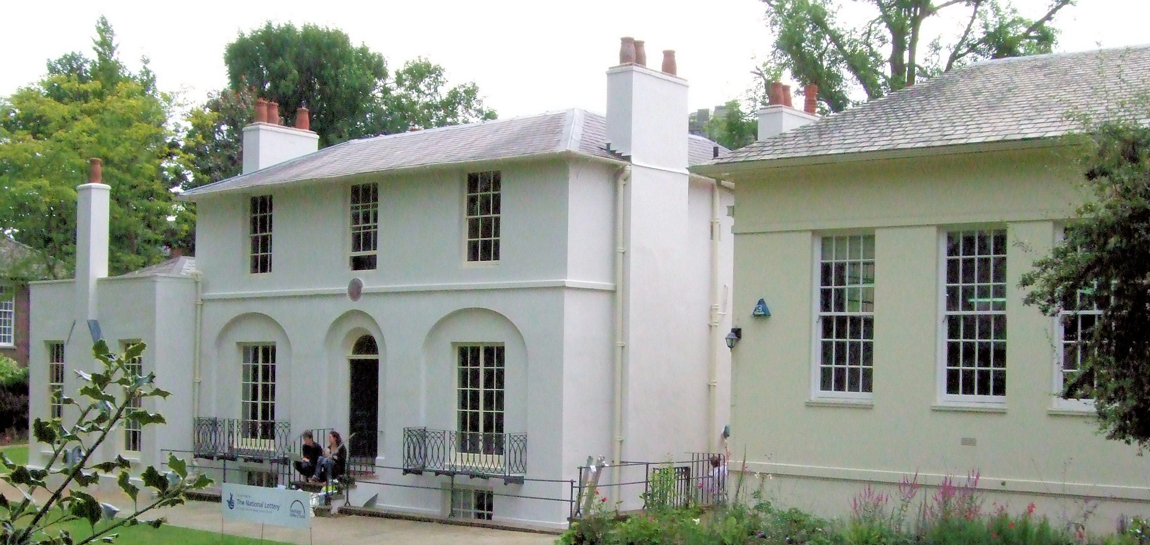
Keats House was built in 1815 as a pair of semi-detached houses known as Wentworth Place. Keats lodged in the smaller dwelling with his friend, Charles Brown from 1818 to 1820.
Edmund had two younger sisters and in 1901, when he was thirteen, he became a pupil at Rugby, a leading public school in Warwickshire. His mother’s sister, Emma Sidebotham, lived at ‘Heathdene’, Langley Road, Watford and the family visited her there.

At the beginning of the twentieth century, many wealthy businessmen, retained a London residence but bought or rented a country house. Bushey Heath, a place known for its healthy air and convenient distance from town, was very popular. In 1902, Edmund’s father purchased ‘Reveley Lodge’, 88 Elstree Road, Bushey Heath and for seven years the family used the house with its conservatory, large garden and tennis court.
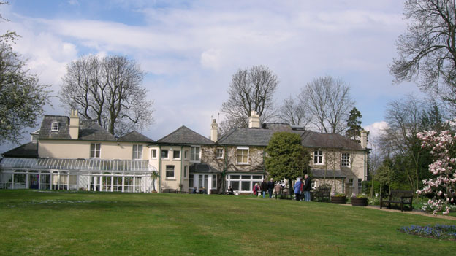
Reveley Lodge, Bushey Heath

In 1909 the house was leased to Mrs Susan Chewett from Canada and her family. At that time of the 1911 census the Johnson family was resident at 50 Downshire Hill, N W London and employed a cook and a parlourmaid. Edmund’s father had retired and his two sisters, Barbara and Helen aged 22 and 20, were living at home. Edmund was not at home at the time of the census and may have been abroad.

By 1914, when Edmund enlisted for service in the First World War, he and his family had moved to Windermere, Westmoreland. He enrolled as Private G/40280 in Whitehall in September 1914 with the Rugby School Public School Battalion, Middlesex Regiment. He was 27 and gave his occupation as a manufacturer.

In February 1915 his younger sister, Helen, married Thomas Hende Roughton in Hampstead. A few months later, Edmund’s father died at the age of 58. Edmund served in France and transferred to the 1st battalion of the Queen’s Royal West Surrey Regiment.

On 24 March 1918, his mother received the news that Helen’s husband, Captain Thomas Hende Roughton MC, had died of wounds in Belgium and on the 12 April Edmund was killed in action. He was 31 and is commemorated on the Ploegsteert Memorial.

‘Reveley Lodge’, in Bushey Heath, where Edmund spent his teenage years, was purchased by Albert Chewett, a former Herkomer art student, in 1921. It remained a private property in the hands of Albert and later of his wife Eila. She died in 2003 and bequeathed the house to Bushey Museum.

